## MATHS VERY IMPORTANT FORMULAS:

* [Additive inverse](https://www.cuemath.com/numbers/additive-inverse/) of [rational number](https://www.cuemath.com/numbers/rational-numbers/): a/b = -b/a
* [Multiplicative Inverse](https://www.cuemath.com/numbers/multiplicative-inverse/) of a/b = c/d , if a/b × c/d = 1
* Distributivity a(b - c) = ab - ac
* [Probability](https://www.cuemath.com/data/probability/) of the occurrence of an event = Number of outcomes that comprise an event/ Total number of outcomes
* [Compound Interest](https://www.cuemath.com/commercial-math/compound-interest/) formula = Amount - Principal, Amount in case the interest is to be calculated annually = Principal ( 1 + Rate/100)n, where ‘n’ is the time period.
* (a - b)2 = a2 - 2ab + b2
* (a + b) (a - b) = a2 - b2
* [Euler’s Formula](https://www.cuemath.com/eulers-formula/): For any polyhedron, Number of faces + Number of vertices - Number of edges = 2
* [Volume of a Cone](https://www.cuemath.com/measurement/volume-of-cone/) = (1 / 3 )πr2h
* [Volume of a Sphere](https://www.cuemath.com/measurement/volume-of-sphere/) = (4/3) π r3

## CHAPTER WISE FORMULAS:

### Rational Numbers

Any number that can be written in the form of p ⁄ q where q ≠ 0 are rational numbers. It possesses the properties of:

* **Additive Identity:**(a ⁄ b + 0) = (a ⁄ b)
* **Multiplicative Identity:**(a ⁄ b) × 1 = (a/b)
* **Multiplicative Inverse:** (a ⁄ b) × (b/a) = 1
* **Closure Property – Addition:**For any two rational numbers a and b, a + b is also a rational number.
* **Closure Property – Subtraction:** For any two rational numbers a and b, a – b is also a rational number.
* **Closure Property – Multiplication:**For any two rational numbers a and b, a × b is also a rational number.
* **Closure Property – Division:**Rational numbers are not closed under division.
* **Commutative Property – Addition:** For any rational numbers a and b, a + b = b + a.
* **Commutative Property – Subtraction:** For any rational numbers a and b, a – b ≠ b – a.
* **Commutative Property – Multiplication:** For any rational numbers a and b, (a x b) = (b x a).
* **Commutative Property – Division:**For any rational numbers a and b, (a/b) ≠ (b/a).
* **Associative Property – Addition:** For any rational numbers a, b, and c, (a + b) + c = a + (b + c).
* **Associative Property – Subtraction:** For any rational numbers a, b, and c, (a – b) – c ≠ a – (b – c)
* **Associative Property – Multiplication:** For any rational number a, b, and c, (a x b) x c = a x (b x c).
* **Associative Property – Division:** For any rational numbers a, b, and c, (a / b) / c ≠ a / (b / c) .
* **Distributive Property:**For any three rational numbers a, b and c, a × ( b + c ) = (a × b) +( a × c).

**Number Formation**

* A two-digit number ‘ab’ can be written in the form: ab = 10a + b
* A three-digit number ‘abc’ can be written as: abc = 100a+10b+c
* A four-digit number ‘abcd’ can be formed: abcd = 1000a+100b+10c+d

### Laws of Exponents

1. a0 = 1
2. a-m = 1/am
3. (am)n = amn
4. am / an = am-n
5. am x bm= (ab)m
6. am / bm= (a/b)m
7. (a/b)-m =(b/a)m
8. (1)n = 1 for infinite values of n.

### Algebraic Identity

Algebraic Identities comprise several equality equations which consist of different variables.

* **Linear Equations in One Variable:** A linear equation in one variable has the maximum one variable of order 1. It is depicted in the form of ax + b = 0, where x is the variable.
* **Linear Equations in Two Variables:** A linear equation in two variables has the maximum of two variables of order 2. It is depicted in the form of ax2 + bx + c = 0.

1. (a + b)2 = a2 + 2ab + b2
2. (a – b)2 = a2 – 2ab + b2
3. (a + b) (a – b) = a2 – b2
4. (x + a) (x + b) = x2 + (a + b)x + ab
5. (x + a) (x – b) = x2 + (a – b)x – ab
6. (x – a) (x + b) = x2 + (b – a)x – ab
7. (x – a) (x – b) = x2 – (a + b)x + ab
8. (a + b)3 = a3 + b3 + 3ab(a + b)
9. (a – b)3 = a3 – b3 – 3ab(a – b)

### Square and Square Roots

If a natural number, m = n2 and n is a natural number, then m is said to be a square number.

* Every square number surely ends with 0, 1, 4, 5, 6, and 9 at its units place.
* A square is the inverse operation of the square.

### Cube and Cube Roots

Numbers, when obtained while multiplied by itself three times, is known as cube numbers.

* If every number in the prime factorisation appears three times, then the number is a perfect cube.
* The symbol of the cube is ∛.
* Cube and Cube mysqladmin: ∛27 = 3 and 33 = 27.

### Comparing Quantities

Discounts are the reduction value prevailed on the Marked Price (MP).

* **Discount = Marked Price – Sale Price**
* **Discount = Discount % of the Marked Price**

Overhead expenses are the additional expenses made after purchasing an item. These are included in the Cost Price (CP) of that particular item.

* **CP = Buying Price + Overhead Expenses**

GST (Goods and Service Tax) is calculated on the supply of the goods.

* **Tax = Tax % of the Bill Amount**

Compound Interest (CI) is the interest which is compounded on the basis of the previous year’s amount.

**Formula of Amount (Compounded Annually):** **\(A = P \left (1 + \frac{R}{100} \right )^t\)**

P = Principal,  
r = Rate of Interest, and  
t = Time Period

**Formula of Amount (Compounded Half Yearly):** **(A = P left (1 + \frac{R}{200} right )^{2t}\)**

R/2 = Half-yearly Rate,  
2t = Number of Half-Years

### Data Handling and Probability

Any useful information that can be utilised for some specific use is known as data. These data can be represented either graphically (pictograph/bar graph/pie charts) or symmetrically (tabular form). Find the important Class 8 Maths formulas for Data Handling and Probability.

* A class interval is the specific range of numbers such as 10-20, 20-30, 30-40, and so forth.
* For a class interval of 10-20, lower class limit = 10 and upper class limit = 20
* Frequency is the number of times a particular value occurs.

Probability = Number of Favourable Outcomes/Total Number of Outcomes

### Geometry

Here, we will define the geometrical formulas consistently used in Mathematics Class 8. We will use the following abbreviations for convenience:

* LSA – Lateral/Curved Surface Area
* TSA – Total Surface Area

|  |  |  |  |  |  |  |  |  |  |  |  |  |  |  |  |  |  |  |  |  |  |  |  |  |
| --- | --- | --- | --- | --- | --- | --- | --- | --- | --- | --- | --- | --- | --- | --- | --- | --- | --- | --- | --- | --- | --- | --- | --- | --- |
| |  |  |  |  | | --- | --- | --- | --- | | SOLID FIGURE | LSA | TSA | VOLUME | | CYLINDER | 2(π × r × h) | 2πr (r + h) | π × r2 × h | | CUBOID | 2h(l + b) | 2(lb + bh + hl) | l × b × h | | CUBE | 4a2 | 6a2 | a3 | | PYRAMID | ½ × p × l | LSA + Area of the base | ⅓ × Area of the base × h | | TOTAL | - | ALL | FOUR | |

## List of Important Class 8 Math Formulas

Consistent practise is essential for success in math. Students are encouraged to solve as many problems as they can, since this will expose them to a variety of formulas. This is a fantastic technique to recall formulas without having to mumble them down. Here is a summarized list of Class 8 math formulas that can be used.

1. Additive inverse of rational number: a/b = -b/a
2. Multiplicative Inverse of a/b = c/d , if a/b × c/d = 1
3. Distributivity a(b – c) = ab – ac
4. Probability of the occurrence of an event = Number of outcomes that comprise an event/ Total number of outcomes
5. Compound Interest formula = Amount – Principal, Amount in case the interest is to be calculated annually = Principal ( 1 + Rate/100)n, where ‘n’ is the time period.
6. (a – b)2 = a2 – 2ab + b2
7. (a + b) (a – b) = a2 – b2
8. Euler’s Formula: For any polyhedron, Number of faces + Number of vertices – Number of edges = 2
9. Volume of a Cone = (1 / 3 )πr2h
10. Volume of a Sphere = (4/3) π r3

# IMPORTANT QUESTIONS

## CHAPTER – 1- RATIONAL NUMBERS:

**1. What are the multiplicative and additive identities of rational numbers?**

**Solution:**0 and 1 are the additive and multiplicative identity of rational numbers respectively.

**2. Write the additive inverse of 19/-6 and -⅔**

**Solution:**19/-6 = 19/6 and -⅔ = 2/3

**3. Write the multiplicative inverse of -13/19 and -7**

**Solution:**-13/19 = -19/13 and -7 = -1/7

**4. Mention a rational number which has no reciprocal.**

**Solution:**A rational number “0” has no reciprocal or multiplicative inverse.

**5. Mention any 4 rational numbers which are less than 5.**

**Solution:**-1, 1, 2 and 3.

### Long Answer Type Questions:

**6. Mention the commutativity, associative and distributive properties of rational numbers. Also, check a × b = b × a and a + b = b + a for a = ½ and b = ¾**

**Solution:**

Commutative property:  
For any two rational numbers a and b, a + b = b + a.  
For any two rational numbers a and b, a × b = b × a.  
Associative Property:  
For any three rational numbers a, b and c,  
(a + b) + c = a + (b + c)  
Distributive property states that for any three numbers x, y and z,  
x × ( y + z ) = (x × y) + ( x × z)

a*b = b*a  
a*b = ½ * ¾ = 3/8  
b*a = ¾ * ½ = 3/8  
a + b = ¾ + ½ = 5/4  
b + a = ½ + ¾ = 5/4

**7. Write any 5 rational numbers between −2/5 and ½.**

**Solution:**  
−2/5 can be written as −8/20.  
1/2 can be written as 10/20.  
So, rational numbers between these two numbers can be,  
−7/20,−6/20,−5/20,−4/20,−3/20,−2/20,−1/20,0,1/20,2/20,3/20,4/20.

**8. If the product of any two rational numbers is 2 and one of them is 1/7, find the other?**

**Solution:**Consider 2 rational numbers as “a” and “b”.

Given, a = 1/7 and a × b = 2

Now, 1/7 × b = 2

⇒ b = 7 × 2 = 14

So, the other rational number will be 14.

**9. Mr X went shopping with a certain amount of money. He spent Rs. 10(¼) on buying a pen and Rs. 25(¾) in food. He then gave the remaining Rs. 16(½) to his friend. Calculate how much money he initially had.**

**Solution:**To get the amount of money Mr X had initially, his purchases have to be added.

So,

Initial Money = 10(¼) + 25(¾) + 16(½)

= 41/4 + 103/4 + 33/2

By taking LCM, we get

Initial Money = 105/2

**10. Represent −𝟐/𝟏𝟏, −𝟓/𝟏𝟏, and −𝟗/ 𝟏𝟏 on the number line.**

**Solution:**To represent these numbers, divide the number line into 11 parts. Now, the given rational numbers will be 2, 5 and 9 points away from 0.

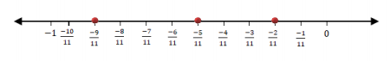

### Extra Practice Questions For Class 8 Maths Chapter 1 Rational Numbers

**1**. Give three rational numbers between 3/6 and 3/4.

**2.**What is the property used for the expression given  -2/3 × 3/5 + 5/2 -3/5 × 1/6 ?

**3.**  Give 2 rational numbers whose multiplicative inverse is same as they are.

**4. Give a rational number that is equivalent to 4/7 with**  
(a) numerator 20  
(b) denominator 28

**5.** What is the additive inverse of 3/4?  
(a) -3/4  
(b) 4/3  
(c) -4/3  
(d) -2/3

## CHAPTER – 2 – LINEAR EQUATION IN ONE VARIABLE:

**Question. 1**:**Solve the following linear equations:**

**(i) x – 11 =7**

**(ii) z + 8 = 9**

**(iii) 11x = 121**

Solution:

(i) x – 11 = 7

x = 7 + 11

x = 18

(ii) z + 8 = 9

z = 9 -8

z =1

(iii) 11x = 121

x = 121/11

x = 11

**Question. 2**: Solve: y/11 = 11

Solution: y/11 = 11

y = 11 × 11

y = 121

**Question. 3**: Solve: 23x/2 = 46

Solution: 23x/2 = 46

x = (46 × 2)/23

x = 2 × 2

x = 4

**Question.4**: Solve 1.2 = z/1.4

Solution: 1.2 = z/1.4

z = 1.2 × 1.4

z = 1.68

**Question.5**:  Solve 7x – 12 = 16

Solution: 7x -12 = 16

7x = 16 + 12

x = 28/7

x = 4

**Question.6**: Solve 7z – 5 = 16

Solution: 7z – 5 = 16

7z = 21

z = 21/7

z =3

**Question.7**: 10 + 6p = 22

Solution: 10 + 6p = 22

6p = 22 – 10

6p = 12

p = 12/6

p = 2

**Question.8**: 11 – 5x + 3x + 4x =18

Solution: 11 – 5x + 3x + 4x = 18

11 – 5x + 7x = 18

2x = 18 -11

x = 7/2

**Question.9**: (x – 2) + (x – 3) + (x – 9) = 0

Solution: (x – 2) + (x – 3) + (x – 9) = 0

x – 2 + x – 3 + x – 9 = 0

3x – 2 – 3 – 9 = 0

3x – 14 = 0

x = 14/3

**Question.10:** (2x-2)+(3x-3)+(9x-9) = 1

Solution: (2x-2)+(3x-3)+(9x-9) = 1

2x – 2 + 3x – 3 + 9x – 9 = 1

14x – 14 = 1

14x = 1 + 14

x = 15/14

**Question.11**:**Solve each of the following equations:**

**(i)x+2 = -11**

Solution: x + 2 = -11

x = -11 -2

x = -13

**(ii) 2x – 1/6 = 3**

Solution: 2x – 1/6 = 3

2x = 3 + 1/6

2x = 19/6

x = 19/12

**(iii)7x – 7 = 21**

Solution: 7x – 7 = 21

7x = 21 + 7

7x = 28

x = 4

**(iv) -7x = 84**

Solution: -7x = 84

-x = 84/7

x = -12

**(v) 18+ 7x = -3**

Solution: 18+ 7x = -3

7x = -3 -18

7x = -21

x = -3

**(vi) 3(x-4) = 21**

Solution: 3(x-4) = 21

3x – 12 = 21

3x = 21 + 12

3x = 33

x = 11

**(vii) 3x/2 – 2x/3 = 8**

Solution: 3x/2 – 2x/3 = 8

(9x – 4x)/6 = 8

5x = 48

x = 48/5

**(Viii) 3x-9 = 4x – 3**

Solution: 3x-9 = 4x – 3

3x – 4x = -3 + 9

-x = 6

x = – 6

**(ix) 3(2x – 3) = 4(2x + 4)**

Solution: 3(2x – 3) = 4(2x + 4)

6x – 9 = 8x + 16

6x – 8x = 16 + 9

-2x = 25

x = -25/2

**Question.12: Solve each of the following equations and check your solution by substituting in the equation.**

**(i) x/2-10=1/2**

Solution: x/2 – 10 = 1/2

(x – 20)/2 = 1/2

x – 20 = 1

x = 21

**(ii) x/3-x/2=6**

x/3 – x/2 =6

(2x – 3x)/6 = 6

-x/6 = 6

-x = 36

x = – 36

**(iii) 6x-9-2(1+x)=x-9**

Solution: 6x – 9 -2(1+x) = x -9

6x -9 -2 – 2x = x – 9

6x – 2x – x = -9 + 9 + 2

3x = 2

x = 2/3

**(iv) 2(x+2)+5(x+5)=4(x-8)+2(x-2)**

Solution: 2(x+2)+5(x+5) = 4(x-8)+2(x-2)

2x + 4 + 5x + 25 = 4x – 32 + 2x – 4

2x + 5x -4x – 2x = -32 – 4 -4 – 25

7x – 6x = -65

x = – 65

**(v) (3+x)/(2x-3) = -1/2**

Solution:  (3+x)/(2x-3) = -1/2  
2 (3 + x) = -1 (2x – 3)

6 + 2x = -2x + 3

4x = 3 -6

x = -3/4

**(vi) (x-7)/3 = (x-1)/5**

Solution: (x-7)/3 = (x-1)/5

5(x-7) = 3(x-1)

5x – 35 = 3x – 3

5x – 3x = -3 + 35

2x = 32

x = 16

### Word Problems

**Question.13: A positive number is 5 time another number. If 21 is added to both the numbers, then one of the new numbers become twice of other new numbers. Find the original numbers.**

Solution: Let the smaller number be x  
And another number = 5x

If 21 is added to both the numbers then as per the given condition;

5x+21 = 2×(x+21)

5x + 21 = 2x + 42

5x – 2x = 42 – 21

3x =. 21

x = 21/3= 7

Therefore, the positive number is = 5×7 = 35

**Question.14: The sum of three consecutive multiples of  8 is 888. Find the multiple.**

Solution: Let the multiples be x, x+8, x+16

Given, the sum of three consecutive multiples of 8 is 888

Thus,

x+x+8+x+16=888

3x+24=888

3x=888-24

3x =864

x =864/3

x =288

Therefore the multiples are:

x =288

x +8=296

x+16=304

**Question.15: Five years ago, Anu was thrice as old as Sonu. After ten years, Anu will be twice as old as Sonu. How old are Anu and Sonu?**

Solution:

Let us assume the present ages of Anu is x and Sonu is y.

According to the question:

x – 5 = 3(y – 5)

x – 5 = 3y – 15

x= 3y-15+5

x= 3y -10  ……………….. (1)

Again, as per question;

x + 10 = 2(y + 10)

x + 10 = 2y + 20

x – 2y = 10

(3y – 10) – 2y = 10 (from equation 1)

3y-2y =10+10

y= 20

Substitute, y=20 in equation 1,

x = 3(20) -10

x =60 – 10

x = 50

Hence, the present ages of Anu is 50 years and of Sonu is 20 years.

**Question 16: Three consecutive integers are as such they are taken in increasing order and multiplied by 2, 3, and 4, respectively, they add up to 56. Find these numbers.**

Solution: Let us say the three consecutive numbers be x, x+1 and x+2.

Now as per the given question;

2×(x)+3×(x+1)+4×(x+2)=56  
9x + 11 = 56  
9x = 56-11  
9x = 45  
x = 45/9  
x= 5

Therefore, the three consecutive numbers are 5, 6 and 7.

**Question 17: The perimeter of a rectangular swimming pool is 154 meters. Its length is 2m more than twice its breadth. What are the length and the breadth of the pool?**

Solution: Let the breadth of the pool =x

Length of the pool will be 2+2x.

Given, Perimeter of the pool = 154 m

We know, for a given rectangle,

Perimeter=2(length+breath)  
By using this formula, we get;

154=2(2+2x+x)

77=2+3x

75=3x

x=25m

Hence, the breadth of the pool is 25m

and Length=2+2×25=52m

**Question 18: Sum of two numbers is 95. If one exceeds the other by 15, find the numbers.**

Solution: Let first number be x

So, second number will be x+15

As per the given question;  
x+x+15=95  
x+x=95-15  
2x=80  
x=80/2  
x=40

x=40

First number = 40

Second number = x+15=40+15=55

Hence, 40 + 55 = 95

**Question 19: The numbers are in the ratio 4:3. If they differ by 18, find these numbers.**

**Solution:**Let the numbers be 4x and 3x

According to the question, the two numbers are differed by 18. Thus,

4x – 3x = 18

=> x = 18

4x = 4 × 18 = 72

3x = 3 × 18 = 54

Therefore, the two numbers are 72 and 54

**Question 20: Three consecutive integers add up to 57. What are these integers?**

Solution:

Let us say the three consecutive numbers be x-1, x and x+1

Now, as per the given question,

x-1+x+x+1=57

3x=57

x=57/3

x=19

Hence,

x-1=19-1=18

x=19

x+1=19+1=20

The three consecutive numbers are 18,19 and 20.

**Question 21: There is a narrow rectangular plot. The length and breadth of the plot are in the ratio of 11:4. At the rate of Rs. 100 per meter it will cost the village panchayat Rs. 75000 to fence the plot. What are the dimensions of the plot?**

Solution: Let the common ratio be x.

Thus, the length and breadth of a rectangular plot be 11x and 4x.

We know that perimeter of rectangal = 2(length + breadth)

Therefore, the perimeter of the plot here is:

= 2(11x + 4x)

= 2(15x)

= 30x.

Given that Cost of fencing the plot at the rate of rs.100 per metre is 75000.

⇒ 100 × Perimeter = 75000

⇒ 100 × 30x = 75000

⇒ 3000x = 75000

⇒ x = 25

So,

Length of rectangular plot = 11x = 275m

Breadth of rectangular plot = 4x = 100m

Hence, the dimensions of the rectangular plot are 275m and 100m respectively.

**Question 22: Convert the following statements into equations.**

**(a) 3 added to a number is 11**

**(b) 2 subtracted from a number is equal to 15.**

**(c) 3 times a number decreased by 2 is 4.**

**(d) 2 times the sum of the number x and 7 is 13.**

Solution:

(a) x +3 = 11

(b) x – 2 = 15

(c) 3x – 2 = 4

(d) = 2(x+7) = 13

**Question 23: Amina thinks of a number and subtracts 5/2 from it. She multiplies the result by 8. the final result is 3 times her original number. Find the number.**

Solution: Let the number thought by Amina be x

She subtracts 5/2 from the number.

x – 5/2

Now, she multiplies the result by 8

8(x – 5/2)

The result obtained is three times her original number;

8(x – 5/2) = 3x

8(x – 5/2) = 3x

8x – 20 = 3x

5x = 20

x = 4

Hence, the number is 4.

**Question 24: A number is 12 more than the other. Find the numbers if their sum is 48.**

Solution: Let the first number be x and the second number be x + 12

As per the given question;

Sum of the two numbers = 48

x + x + 12 = 48

2x + 12 = 48

2x = 48 – 12

2x = 36

x = 36/2

x = 18

Therefore, x = 18 and x+12= 18+12=30

So the answer is 18 and 30.

**Question 25: The sum of three consecutive odd numbers is 51. Find the numbers.**

Solution: Let the three consecutive odd numbers are x, x+2 and x+4.

As per the given question, the sum all the three numbers is 51

Therefore,

x+x+2+x+4=51

3x+6=51

x=(51-6)/3=45/3 =15

Hence the numbers are:

x=15

x+2=17

x+4=19

Therefore, the required three consecutive odd numbers are 15,17 and 19.

**Question 26: Jane is 6 years older than her younger sister. After 10 years, the sum of their ages will be 50 years. Find their present ages.**

Solution: Let the age of Jane’s younger sister is x.

Age of Jane will be x + 6

As per the question, after 10 years the sum of their ages will be 50.

After 10 years,

age of Jane = x + 16

age of her younger sister = x + 10

Therefore,

x + 16 + x +10 = 50

2x + 26 = 50

2x = 24

x = 12

Hence, the present age of Jane’s younger sister is 12 years.

And of Jane’s is 12+6 = 18 years.

**Question 27: The denominator of a fraction is greater than the numerator by 8. If the numerator is increased by 17 and denominator is decreased by 1, the number obtained is 3/2. Find the fraction.**

Solution: Let numerator of a fraction be x.

Denominator = ( x + 8 )

Fraction = Numerator/Denominator = x/x+8

According to the question,

(x + 17) / (x + 8 – 1) = 3/2

(x + 17) / (x + 7) = 3/2

2 ( x + 17 ) = 3 ( x + 7 )

2x + 34 = 3x + 21

3x – 2x = 34 – 21

x = 13

Numerator = x = 13

And

Denominator = X + 8 = 13+8 = 21

Fraction = 13/21

**Question 28: A sum of Rs.2700 is to be given in the form of 63 prizes. If the prize is of either Rs.100 or Rs.25, find the number of prizes of each type.**

Solution: Let the number of prizes of Rs. 100 be =x, and worth rs.25 be y.

Given that,

100x+25y= 2700

Simplify the above equation, we get

4x+y= 108 ….(1)

As per the given question;

x+y= 63 ….(2)

Now, solve equation (1) and (2), we get

3x= 45

x= 15

Now, substitute x= 15 in equation (2), we get

15+y= 63

y=63-15

y=48

Hence, the number of prizes worth Rs. 1oo is 15 and the number of prizes worth Rs. 25 is 48.

**Question 29: In an isosceles triangle, the base angles are equal, and the vertex angle is 80 degrees. Find the measure of the base angles.**

Solution: Let the base angle of the isosceles triangle is x.

Since the two sides of the isosceles triangle are equal, therefore its base angles are also equal.  
By angle sum property of triangle, we know;

2x+80=180

2x=180-80

2x=100

x=50

Hence, the measure of both the base angles is equal to 50 degrees.

### Extra Practice Questions For Class 8 Maths Chapter 2 Linear Equations in One Variable

1. The tens and unit digits of a number are the same. By adding the number to its reverse, you get the sum 110. Calculate the number.

2. A man sold his bicycle for an amount that is over Rs 988 by half the price that he paid for it. He made a profit of Rs, 300. Now, what was the original cost of the bicycle?

3. Sum of two numbers were given as 2490. If 6.5% of one number is equal to 8.5% of another number, then find the value of both the numbers.

## CHAPTER – 3 – UNDERSTANDING QUADRILATERALS:

**Q.1: A quadrilateral has three acute angles, each measure 80°. What is the measure of the fourth angle?**

Solution:

Let x be the measure of the fourth angle of a quadrilateral.

Sum of the four angles of a quadrilateral = 360°

80° + 80° + 80° + x = 360°

x = 360° – (80° + 80° + 80°)

x = 360° – 240°

x = 120°

Hence, the fourth angle is 120°.

**Q,2: In a quadrilateral ABCD, the measure of the three angles A, B and C of the quadrilateral is 110°, 70° and 80°, respectively. Find the measure of the fourth angle.**

Solution: Let,

∠A = 110°

∠B = 70°

∠C = 80°

∠D = x

We know that the sum of all internal angles of quadrilateral ABCD is 360°.

∠A + ∠B+ ∠C+∠D = 360°

110° + 70° + 80° + x = 360°

260° + x = 360°

x = 360° – 260°

x = 100°

Therefore, the fourth angle is 100°.

**Q.3: In a quadrilateral ABCD, ∠D is equal to 150° and ∠A = ∠B = ∠C. Find ∠A, ∠B and ∠C.**

Solution: Given,

∠D = 150°

Let ∠A = ∠B = ∠C = x

By angle sum property of quadrilateral,

∠A + ∠B + ∠C + ∠D = 360°

x + x +x+∠D = 360°

3x+∠D = 360°

3x = 360° – ∠D

30 = 360° – 150°

3x = 210°

x = 70°

Hence, ∠A = ∠B = ∠C = 70°.

**Q.4: The angles of a quadrilateral are in the ratio of 1 : 2 : 3 : 4. What is the measure of the four angles?**

Solution: Given,

The ratio of the angles of quadrilaterals = 1 : 2 : 3 : 4

Let the four angles of the quadrilateral be x, 2x, 3x, and 4x respectively.

The sum of four angles of a quadrilateral is 360°.

Therefore,

x + 2x + 3x + 4x = 360°

10x = 360°

x = 360°/10

x = 36°

Therefore,

First angle = x = 36°

Second angle = 2x = 2 × 36 = 72°

Third angle = 3x = 3 × 36 = 108°

Fourth angle = 4x = 4 × 36 = 144°

Hence, the measure of four angles is 36°, 72°, 108° and 144°.

**Q. 5: In quadrilaterals,**

**(i) which of them have their diagonals bisecting each other?**

**(ii) which of them have their diagonal perpendicular to each other?**

**(iii) which of them have equal diagonals?**

Solution:

(i) Diagonals bisect each other in:

* Parallelogram
* Rhombus
* Rectangle
* Square
* Kite

(ii) Diagonals are perpendicular in:

* Rhombus
* Square
* Kite

(iii) Diagonals are equal to each other in:

* Rectangle
* Square

**Q. 6: Adjacent sides of a rectangle are in the ratio 5 : 12, if the perimeter of the rectangle is 34 cm, find the length of the diagonal.**

Solution:  
Given,  
Ratio of the adjacent sides of the rectangle = 5 : 12  
Let 5x and 12x be the two adjacent sides.  
We know that the sum of all sides of a rectangle is equal to its perimeter.  
Thus,  
5x + 12x + 5x + 12x = 34 cm (given)  
34x = 34  
x = 34/34  
x = 1 cm  
Therefore, the adjacent sides are 5 cm and 12 cm respectively.  
i.e. l = 12 cm, b = 5 cm  
Length of the diagonal = √(l2 + b2)  
= √(122 + 52)  
= √(144 + 25)  
= √169  
= 13 cm  
Hence, the length of the diagonal is 13 cm.

**Q. 7: The opposite angles of a parallelogram are (3x + 5)° and (61 – x)°. Find the measure of four angles.**

Solution:  
Given,  
(3x + 5)° and (61 – x)° are the opposite angles of a parallelogram.  
We know that the opposite angles of a parallelogram are equal.  
Therefore,  
(3x + 5)° = (61 – x)°  
3x + x = 61° – 5°  
4x = 56°  
x = 56°/4  
x = 14°  
⇒ 3x + 5 = 3(14) + 5 = 42 + 5 = 47  
61 – x = 61 – 14 = 47  
The measure of angles adjacent to the given angles = 180° – 47° = 133°  
Hence, the measure of four angles of the parallelogram are 47°, 133°, 47°, and 133°.

**Q. 8: ABCD is a parallelogram with ∠A = 80°. The internal bisectors of ∠B and ∠C meet each other at O. Find the measure of the three angles of ΔBCO.**

Solution:  
Given,  
∠A = 80°

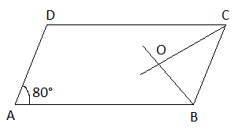

We know that the opposite angles of a parallelogram are equal.  
∠A = ∠C = 80°  
And  
∠OCB = (1/2) × ∠C  
= (1/2) × 80°  
= 40°  
∠B = 180° – ∠A (the sum of interior angles on the same side of the transversal is 180)  
= 180° – 80°  
= 100°  
Also,  
∠CBO = (1/2) × ∠B  
= (1/2) × 100°  
= 50°  
By the angle sum property of triangle BCO,  
∠BOC + ∠OBC + ∠CBO = 180°  
∠BOC = 180° – (∠OBC + CBO)  
= 180° – (40° + 50°)  
= 180° – 90°  
= 90°  
Hence, the measure of all the three angles of a triangle BCO is 40°, 50° and 90°.

**Q. 9: Find the measure of all four angles of a parallelogram whose consecutive angles are in the ratio 1 : 3.**

Solution:  
Given,  
The ratio of two consecutive angles of a parallelogram = 1 : 3  
Let x and 3x be the two consecutive angles.  
We know that the sum of interior angles on the same side of the transversal is 180°.  
Therefore, x + 3x = 180°  
4x = 180°  
x = 180°/4  
x = 45°  
⇒ 3x = 3(45°) = 135°  
Thus, the measure of two consecutive angles is 45° and 135°.  
As we know, the opposite angles of a parallelogram are equal.  
Hence, the measure of all the four angles is 45°, 135°, 45°, and 135°.

**Q. 10: A diagonal and a side of a rhombus are of equal length. Find the measure of the angles of the rhombus.**

Solution:  
Let ABCD be the rhombus.  
Thus, AB = BC = CD = DA

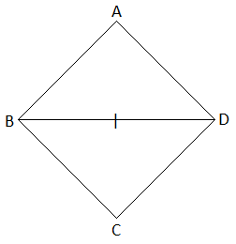  
Given that a side and diagonal are equal.  
AB = BD (say)  
Therefore, AB = BC = CD = DA = BD  
Now, all the sides of a triangle ABD are equal.  
Therefore, ΔABD is an equilateral triangle.  
Similarly,  
ΔBCD is also an equilateral triangle.  
Thus, ∠A = ∠ABD = ∠ADB = ∠DBC = ∠C = ∠CDB = 60°  
∠B = ∠ABD + ∠DBC = 60° + 60° = 120°  
And  
∠D = ∠ADB + ∠CDB = 60° + 60° = 120°  
Hence, the angles of the rhombus are 60°, 120°, 60° and 120°.

### Extra Practice Questions For Class 8 Maths Chapter 3 Understanding Quadrilateral

1. How many sides do a regular polygon have, if the measure of an exterior angle is given as 24° ?

2. What is the measure of each exterior angle of a regular polygon of 15 sides?  
(a) 30°  
(b) 45°  
(c) 60°  
(d) 24°

3.  When the sum of the internal angles of a polygon is 10 right angles, then how many sides does it have?  
(a) 6  
(b) 5  
(c) 8  
(d) 7

4. Select a false statement from those given below:  
(a) A square is a rectangle that has equal adjacent sides  
(b) A square is a rhombus whose one angle is a right angle  
(c) The diagonals of a square bisect each other at right angles  
(d) The diagonals of a square do not divide the whole square into four equal parts.

5. When one angle of a parallelogram is a right angle, then what is the name of the quadrilateral?  
(a) kite  
(b) rectangle  
(c) rhombus  
(d) square

## CHAPTER – 4 – PRACTICAL GEOMETRY

**Q.1: Construct a quadrilateral ABCD where AB = 4.5 cm BC = 5.5 cm CD = 4 cm AD = 6 cm AC = 7 cm.**

**Solution:**

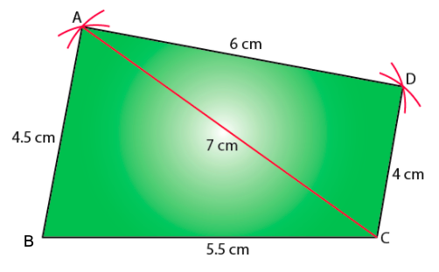

**Q.2: Construct a quadrilateral JUMP where JU = 3.5 cm UM = 4 cm MP = 5 cm PJ = 4.5 cm PU = 6.5 cm.**

**Solution:**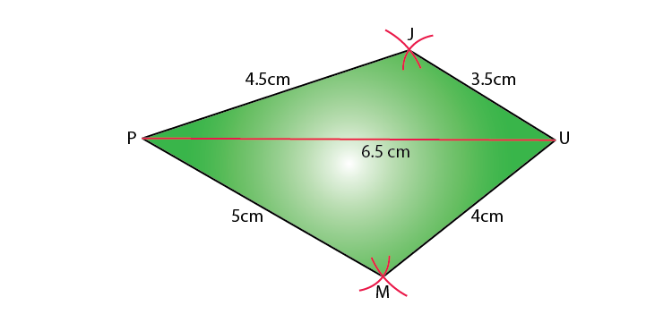

**Q.3: Construct a Rhombus BEND with BN = 5.6 cm DE = 6.5 cm.**

**Solution:**

As we know, the diagonals of a rhombus bisect each other at a right angle.

Let us consider that these diagonals intersect each other at a point O in rhombus.

Hence, EO = OD = 3.25 cm

Here is a rough sketch of the rhombus BEND:

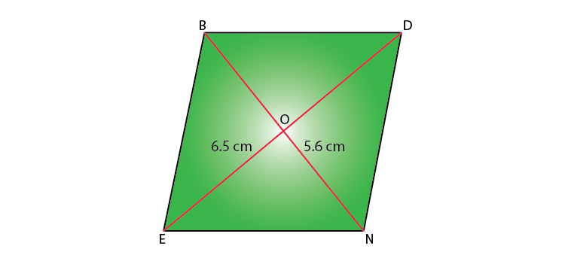

Step 1: Draw a line segment BN of 5.6 cm and also draw its perpendicular bisector. It will intersect the line segment BN at point O.

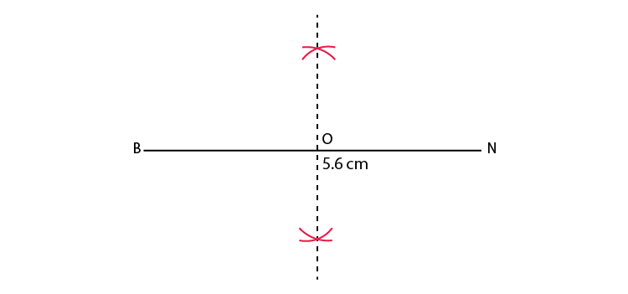

Step 2: Taking O as the centre, draw arcs of 3.25 cm radius to intersect the perpendicular bisector at point D and E.

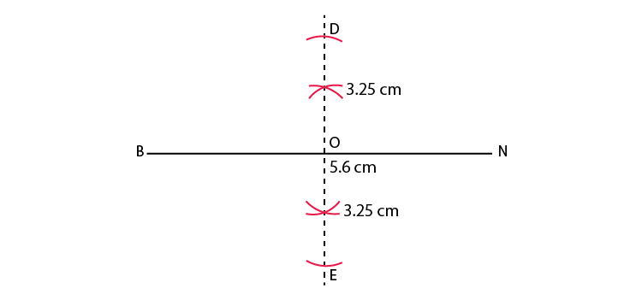

Step 3: Join points D and E to points B and N.

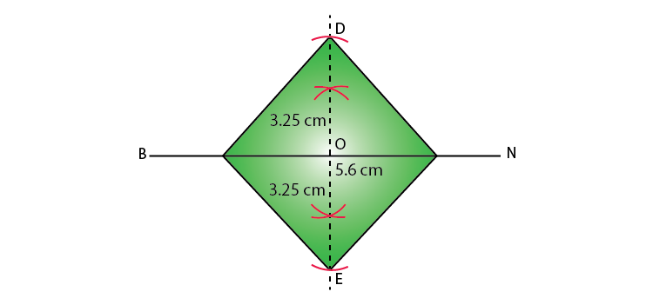

BEND is the required Rhombus.

**Q.4: Construct a Quadrilateral PLAN with PL = 4 cm LA = 6.5 cm ∠P = 90° ∠A = 110° ∠N = 85°.**

**Solution:**

The sum of four angles of a quadrilateral is 360°.

In quadrilateral PLAN,

∠P + ∠L + ∠A + ∠N = 360°

90° + ∠L + 110° + 85° = 360°

285° + ∠L = 360°

∠L = 360° − 285° = 75°

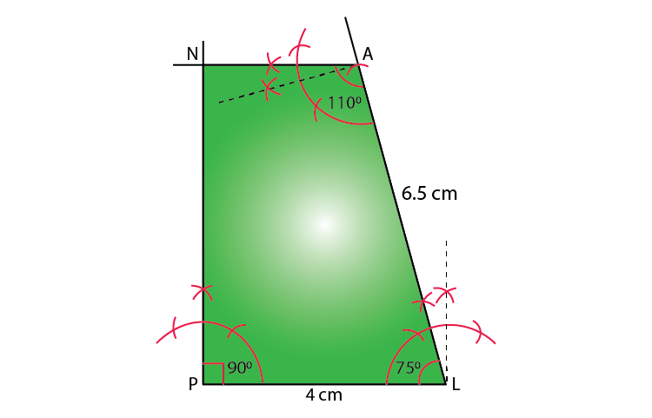

Q.5: Construct a Parallelogram HEAR where HE = 5 cm EA = 6 cm ∠R = 85° .

Solution:

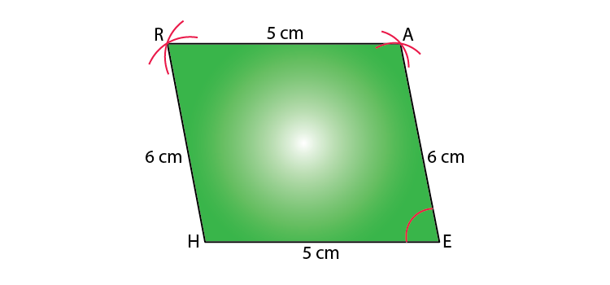

**Q.6: Construct a Quadrilateral DEAR where DE = 4 cm EA = 5 cm AR = 4.5 cm ∠E = 60°.**

**Solution:**

Step 1: Draw a line segment DE of 4 cm and an angle of 60º at point E. As A is 5 cm away from E, cut the line segment EA 5 cm from point E on this ray.

Step 2: Again draw an angle of 90º at point A. As R is 4.5 cm away from A, cut a line segment RA of 4.5 cm from A on this ray.

Step 3: Join D to R.

DEAR is the required quadrilateral.

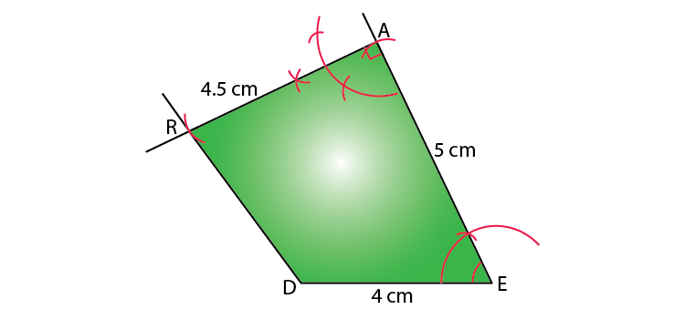

**Also check:**

* [Important 2 Marks Question For Cbse Class 8 Maths](https://byjus.com/maths/important-2-marks-question-for-cbse-class-8-maths/)
* [Important 3 Marks Questions For Cbse Class 8 Maths](https://byjus.com/maths/important-3-marks-questions-for-cbse-class-8-maths/)
* [Important 4 Marks Questions For Cbse Class 8 Maths](https://byjus.com/maths/important-4-marks-questions-for-cbse-class-8-maths/)

### Class 8 Chapter 4 -Practical Geometry Extra Questions

* 1. Construct a quadrilateral PQRS where PQ = 4.4 cm, QR = 4 cm, RS = 6.4 cm, SP = 3.8 cm and PR = 6.6 cm.
  2. Construct a quadrilateral PQRS where PQ = 5.4 cm, QR = 2.5 cm, RS = 4 cm, SP =6.5 cm and PR = 5cm.
  3. Construct a quadrilateral PQRS where PQ = 4 cm, QR = 5.6 cm, RS = 4.5 cm, SP = 5 cm AND PR = 6.5cm.
  4. Construct a quadrilateral PQRS where PQ = 3.6 cm, QR = 5.5 cm, RS = 5 cm ∠B = 125° and ∠C= 80°.
  5. Construct a quadrilateral PQRS where PQ = 6 cm, QR = 4 cm, RS = 4 cm, ∠Q = 95° and ∠R= 90°.
  6. Construct a quadrilateral PQRS where PQ = 4 cm, QR = 3 cm, ∠P = 75° ∠Q = 80° and ∠R= 120°
  7. Construct a quadrilateral PQRS where PQ = 4 cm, QR = 5 cm, ∠P = 50°,∠Q = 110° and ∠R= 70°.
  8. Construct a quadrilateral PQRS where PQ = 6 cm, QR = 6 cm, RS = SP = 4.5 cm ∠Q = 120°
  9. Construct a quadrilateral PQRS where PQ = 7.5 cm, QR = 6 cm, RS = 6 cm, SP =5 cm and PR = 10 cm.
  10. Construct a quadrilateral PQRS where PQ = 5 cm, QR = 5.5 cm, RS = 2.5 cm, SP = 7.1 cm and PR = 8cm.
  11. Construct the following Quadrilateral ABCD  
      AB = 4.5 cm  
      BC = 5.5 cm  
      CD = 4 cm  
      AD = 6 cm  
      AC = 7 cm
  12. Draw a rhombus with 5.2 cm and 6.4 cm long diagonals.

## CHAPTER – 5 – DATA HANDLING:

**The weekly wages (in Rs.) of 30 workers in a factory are: 830,  835, 890, 810, 835, 836, 869, 845, 898, 890,820, 860, 832, 833, 855, 845, 804, 808, 812, 840, 885, 835, 835, 836, 878, 840, 868, 890, 806, 840.**

**Using tally marks, make a frequency table with intervals as 800 – 810, 810 – 820 and so on.**

**Solution:** The frequency table with intervals as 800 – 810, 810 – 820 and so on, using tally marks is given below:

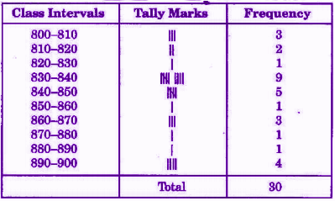

**Q.2: The number of hours for which students of a particular class watched television during holidays is shown through the given graph. Answer the following:**

**(i) For how many hours did the maximum number of students watch T.V.?**

**(ii) How many students watched TV for less than 4 hours?**

**(iii) How many students spent more than 5 hours watching TV?**

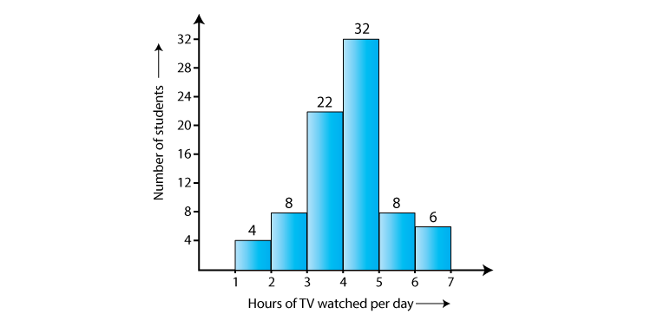

**Solution:**

(i) 32 students watched T.V for 4-5 hours.

Therefore, the maximum number of students who watched T.V. for 4 – 5 hours.

(ii) The number of students who watched T.V. less than 4 hours = 22 + 8 + 4 = 34

(iii) The number of students who spent more than 5 hours watching TV = 8 + 6 = 14

**Q.3: A survey was made to find the type of music that a certain group of young people liked in a city. The adjoining pie chart shows the findings of this survey. From this pie chart, answer the following:**

**(i) If 20 people liked classical music, how many young people were surveyed?**

**(ii) Which type of music is liked by the maximum number of people?**

**(iii) If a cassette company were to make 1000 CD’s, how many of each type would they make?**

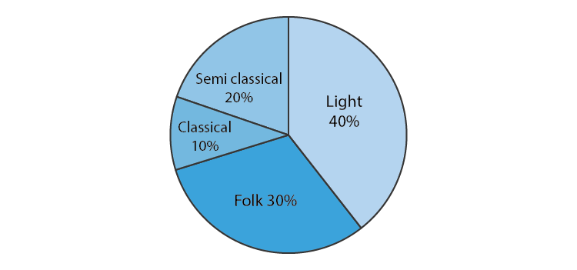

**Solution:**

(i) 10% represents 20 people.

⟹100% represents = (100 x 20)/10 = 200

Therefore, 200 people were surveyed.

(ii) Since 40% of the total people surveyed liked light music and no other form of song liked more than that, we can conclude that the maximum number of people likes light music.

(iii) CD’s of classical music = (10 x 1000)/100 = 100

CD’s of semi-classical music = (20 x 1000)/100 = 200

CD’s of light music = (40 x 1000)/100 = 400

CD’s of folk music = (30 x 1000)/100 = 300

**Q.4: The adjoining pie chart gives the marks scored in an examination by a student in Hindi, English, Mathematics, Social Science and Science. If the total marks obtained by the students were 540, answer the following questions.**

**(i) In which subject did the student score 105 marks?**

**(ii) How many more marks were obtained by the student in Mathematics than in Hindi?**

**(iii) Examine whether the sum of the marks obtained in Social Science and Mathematics is more than that in Science and Hindi.**

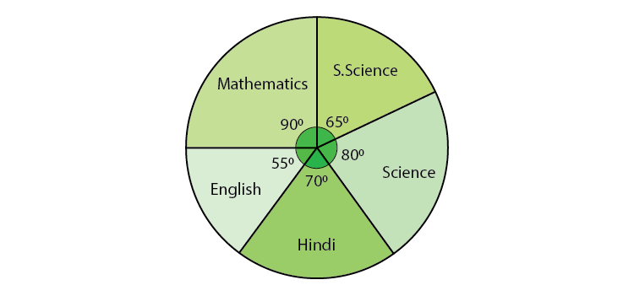

Solution:

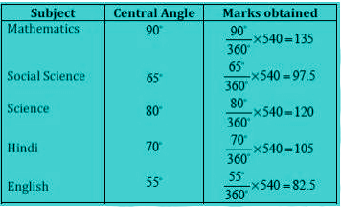

(i) The student scored 105 marks in Hindi.

(ii) Marks obtained in Mathematics = 135 Marks obtained in Hindi = 105

Difference = 135 – 105 = 30

Thus, 30 more marks were obtained by the student in Mathematics than in Hindi.

(iii) The total marks obtained in Social Science and Mathematics = 97.5 + 135 = 232.5

The total marks obtained in Science and Hindi = 120 + 105 = 225

Therefore, the sum of the marks in Social Science and Mathematics is more than that in Science and Hindi.

**Q.5: The number of students in a hostel, speaking different languages is given below. Display the data in a pie chart.**

|  |  |  |  |  |  |  |
| --- | --- | --- | --- | --- | --- | --- |
| **Language** | **Hindi** | **English** | **Marathi** | **Tamil** | **Bengali** | **Total** |
| **No. of students** | **40** | **12** | **9** | **7** | **4** | **72** |

Solution:

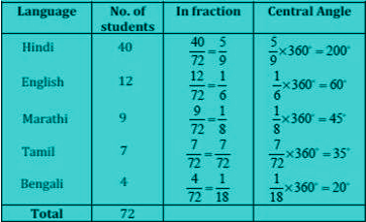

The pie-chart for the above data will be:

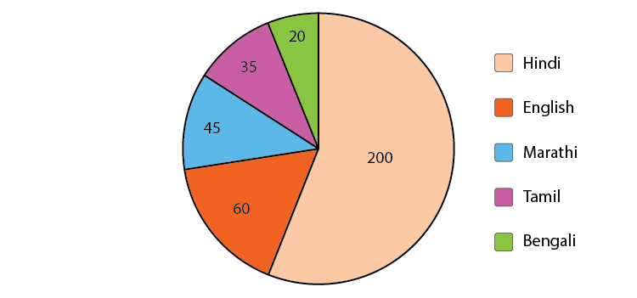

**Q.6: When a die is thrown, list the outcomes of an event of getting:**

**(i)**

**(a) a prime number**

**(b) not a prime number**

**(ii)**

**(a) a number greater than 5**

**(b) a number not greater than 5.**

Solution:

(i)

(a) Outcomes of the event to get a prime number are 2, 3 and 5.

(b) Outcomes of an event of not getting a prime number are 1, 4 and 6.

(ii)

(a) Outcomes of the event of getting a number greater than 5 are 6.

(b) Outcomes of the event of not getting a number greater than 5 are 1, 2, 3, 4 and 5.

**Q.7: Numbers 1 to 10 are written on ten separate slips (one number on one slip), kept in a box and mixed well. One slip is chosen from the box without looking into it. What is the probability of:**

**(i) getting a number 6?**

**(ii) getting a number less than 6?**

**(iii)getting a number greater than 6?**

**(iv)getting a 1-digit number?**

**Solution:**

(i) The outcome of getting a number 6 from ten separate slips is one.

Therefore, the probability of getting a number 6 = 1/10

(ii) Numbers which are less than 6 are 1, 2, 3, 4 and 5. So total there are five numbers. Thus, there are 5 outcomes.

Therefore, the probability of getting a number less than 6 = 5/10 = ½

(iii) The number is greater than 6 out of ten that are 7, 8, 9, 10. So there are 4 possible outcomes.

Therefore, the probability of getting a number greater than 6 = 4/10 = ⅖

(iv) One digit numbers out of 1 to 10 are 1, 2, 3, 4, 5, 6, 7, 8, 9.

Therefore, the probability of getting a 1-digit number = 9/10

**Q.8: If you have a spinning wheel with 3 green sectors, 1 blue sector and 1 red sector, what is the probability of getting a green sector? What is the probability of getting a non-blue sector?**

Solution: A total of five sectors are present. Out of the five sectors, three sectors are green.

Therefore, the probability of getting a green sector = ⅗

Out of the five sectors, one sector is blue.

Hence, Number of Non-blue sectors = 5 – 1 = 4 sectors

Therefore, the probability of getting a non-blue sector will be equal to 4/5.

### Extra Questions For Class 8 Maths Data Handling

Solve these extra questions given below, to check your skills for this particular chapter.

1. In a deck of 52 cards, what is the probability of getting:
   * Black cards
   * Red Cards
   * Face Cards
2. When a die is thrown, what is the probability of getting a prime number?
3. Draw a Bar Graph for the given data:

|  |  |  |  |  |  |  |
| --- | --- | --- | --- | --- | --- | --- |
| School Supplies | Clip Board | crayon | Folder | Highlighter | Notebook | Binder |
| Items Sold | 6 | 7 | 7 | 9 | 12 | 14 |

4. Construct a pie chart for the given data:

|  |  |  |  |  |
| --- | --- | --- | --- | --- |
| Method of travel | Walk | Bike | Car | Bus |
| Frequency | 9 | 3 | 6 | 12 |

5. If you have a spinning wheel with 3 green sectors, 1 blue sector and 1 red sector, what is the probability of getting a green sector? What is the probability of getting a non-blue sector?

6. Which of the following need a histogram to show the data?  
(i) The number of letters for different areas in a postman’s bag.  
(ii) The height of competitors in an athletics meet.  
(iii) The number of cassettes produced by 5 companies.  
(iv) The number of passengers boarding trains from 7 a.m to 7 p.m at a station.

7. When a die is thrown, list out the outcomes of an event that shows  
(i) (a) a prime number  
(b) not a prime number  
(ii) (a) a number greater than 5  
(b) a number not greater than 5

## CHAPTER – 6 – SQUARES AND SQUARE ROOTS:

**Q.1: How many numbers lie between squares of the following numbers?**

**(i) 12 and 13**

**(ii) 25 and 26**

**(iii) 99 and 100**

Solution: As we know, between n2 and (n+1)2, the number of non–perfect square numbers are 2n.

(i) Between 122 and 132 there are 2×12 = 24 natural numbers.

(ii) Between 252 and 262 there are 2×25 = 50 natural numbers.

(iii) Between 992 and 1002 there are 2×99 =198 natural numbers.

**Q.2: Write a Pythagorean triplet whose one member is:**

**(i) 6**

**(ii) 14**

**(iii) 16**

**(iv) 18**

Solution:

We know, for any natural number m, 2m, m2–1, m2+1 is a Pythagorean triplet.

(i) 2m = 6

⇒ m = 6/2 = 3

m2–1= 32 – 1 = 9–1 = 8

m2+1= 32+1 = 9+1 = 10

Therefore, (6, 8, 10) is a Pythagorean triplet.

(ii) 2m = 14

⇒ m = 14/2 = 7

m2–1= 72–1 = 49–1 = 48

m2+1 = 72+1 = 49+1 = 50

Therefore, (14, 48, 50) is not a Pythagorean triplet.

(iii) 2m = 16

⇒ m = 16/2 = 8

m2–1 = 82–1 = 64–1 = 63

m2+ 1 = 82+1 = 64+1 = 65

Therefore, (16, 63, 65) is a Pythagorean triplet.

(iv) 2m = 18

⇒ m = 18/2 = 9

m2–1 = 92–1 = 81–1 = 80

m2+1 = 92+1 = 81+1 = 82

Therefore, (18, 80, 82) is a Pythagorean triplet.

**Q.3: (n+1)2-n2 = ?**

Solution:

(n+1)2-n2

= (n2 + 2n + 1) – n2

= 2n + 1

**Q.4: Show that 121 is the sum of 11 odd natural numbers.**

Solution: As 121 = 112

We know that the sum of first n odd natural numbers is n2.

Therefore, 121 = sum of first 11 odd natural numbers

= 1 + 3 + 5+ 7 + 9 + 11 +13 + 15 + 17 + 19 + 21

**Q.5: Show that the sum of two consecutive natural numbers is 132.**

Solution:

Let 2n + 1 = 13

So, n = 6

So, ( 2n + 1)2 = 4n2 + 4n + 1

= (2n2 + 2n) + (2n2 + 2n + 1)

Substitute n = 6,

(13)2 = ( 2 x 62 + 2 x 6) + (2 x 62 + 2 x 6 + 1)

= (72 + 12) + (72 + 12 + 1)

= 84 + 85

**Q.6: Use the identity and find the square of 189.**

**(a – b)2= a2 – 2ab + b2**

Solution: 189 = (200 – 11)2

= 40000 – 2 x 200 x 11 + 112

= 40000 – 4400 + 121

= 35721

**Q.7: What would be the square root of 625 using the identity (a +b)2 = a2 + b2 + 2ab?**

Solution: (625)2

= (600 + 25)2

= 6002 + 2 x 600 x 25 +252

= 360000 + 30000 + 625

= 390625

**Q.8: Find the square roots of 100 and 169 by the method of repeated subtraction.**

Solution:

Let us find the square root of 100 first.

1. 100 – 1 = 99
2. 99 – 3 = 96
3. 96 – 5 = 91
4. 91 – 7 = 84
5. 84 – 9 = 75
6. 75 – 11 = 64
7. 64 – 13 = 51
8. 51 – 15 = 36
9. 36 – 17 = 19
10. 19 – 19 = 0

Here, we have performed a subtraction ten times.

Therefore, √100 = 10

Now, the square root of 169:

1. 169 – 1 = 168
2. 168 – 3 = 165
3. 165 – 5 = 160
4. 160 – 7 = 153
5. 153 – 9 = 144
6. 144 – 11 = 133
7. 133 – 13 = 120
8. 120 – 15 = 105
9. 105 – 17 = 88
10. 88 – 19 = 69
11. 69 – 21 = 48
12. 48 – 23 = 25
13. 25 – 25 = 0

Here, we have performed subtraction thirteen times.

Therefore, √169 = 13

**Q.10: Find the square root of 729 using factorisation method.**

Solution:

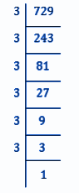

729 = 3×3×3×3×3×3×1

⇒ 729 = (3×3)×(3×3)×(3×3)

⇒ 729 = (3×3×3)×(3×3×3)

⇒ 729 = (3×3×3)2

Therefore,

⇒ √729 = 3×3×3 = 27

**Q. 11: Find the smallest whole number by which 1008 should be multiplied so as to get a perfect square number. Also, find the square root of the square number so obtained.**

Solution:

Let us factorise the number 1008.

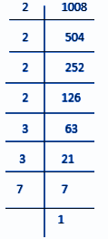

1008 = 2×2×2×2×3×3×7

= (2×2)×(2×2)×(3×3)×7

Here, 7 cannot be paired.

Therefore, we will multiply 1008 by 7 to get a perfect square.

New number so obtained = 1008×7 = 7056

Now, let us find the square root of 7056

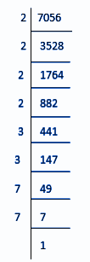

7056 = 2×2×2×2×3×3×7×7

⇒ 7056 = (2×2)×(2×2)×(3×3)×(7×7)

⇒ 7056 = 22×22×32×72

⇒ 7056 = (2×2×3×7)2

Therefore;

⇒ √7056 = 2×2×3×7 = 84

**Q. 12: Find the smallest whole number by which 2800 should be divided so as to get a perfect square.**

Solution:

Let us first factorise the number 2800.

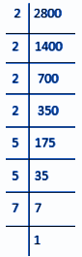

2800 = 2×2×2×2×5×5×7

= (2×2)×(2×2)×(5×5)×7

Here, 7 cannot be paired.

Therefore, we will divide 2800 by 7 to get a perfect square.

New number = 2800 ÷ 7 = 400

**Q. 13: 2025 plants are to be planted in a garden in such a way that each row contains as many plants as the number of rows. Find the number of rows and the number of plants in each row.**

Solution:

Let the number of rows be, x.

Therefore, the number of plants in each row = x.

Total many contributed by all the students = x×x = x2

Given, x2 = Rs.2025

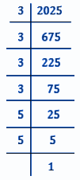

x2= 3×3×3×3×5×5

⇒ x2 = (3×3)×(3×3)×(5×5)

⇒ x2 = (3×3×5)×(3×3×5)

⇒ x2 = 45×45

⇒ x = √(45×45)

⇒ x = 45

Therefore,

Number of rows = 45

Number of plants in each rows = 45

**Q.14: Find the smallest square number that is divisible by each of the numbers 8, 15 and 20.**

Solution:

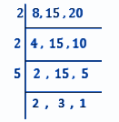

L.C.M of 8, 15 and 20 is (2×2×5×2×3) = 120.

120 = 2×2×3×5×2 = (2×2)×3×5×2

Here, 3, 5 and 2 cannot be paired.

Therefore, we need to multiply 120 by (3×5×2) i.e. 30 to get a perfect square.

Hence, the smallest squared number which is divisible by numbers 8, 15 and 20 = 120×30 = 3600

**Q.15: Find the square root of 7921 using long division method.**

Solution:

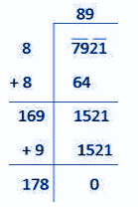

∴ √7921 = 89

**Q. 16: Find the square root of 42.25 using long division method.**

Solution:

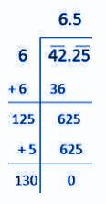

∴ √42.25 = 6.5

**Q. 17: Find the least number which must be added to 1750 so as to get a perfect square. Also, find the square root of the obtained number.**

Solution:

Using long division method:

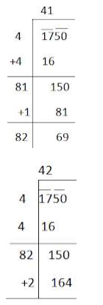

Here, (41)2 < 1750 > (42)2

We can say 1750 is ( 164 – 150 ) = 14 less than (42)2.

Therefore, if we add 14 to 1750, it will be a perfect square.

New number = 1750 + 14 = 1764

Therefore, the square root of 1764 is as follows:

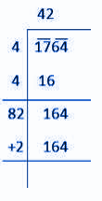

∴√1764 = 42

## CHAPTER – 7- CUBES AND CUBE ROOTS:

**Q.1: Find the cube of 3.5.**

Solution: 3.53 = 3.5 x 3.5 x 3.5

= 12.25 x 3.5

= 42.875

**Q.2: Is 392 a perfect cube? If not, find the smallest natural number by which 392 should be multiplied so that the product is a perfect cube.**

Solution: The prime factorisation of 392 gives:

392 = 2 x 2 x 2 x 7 x 7

Since, we can see, number 7 cannot be paired in a group of three. Therefore, 392 is not a perfect cube.

To make it a perfect cube, we have to multiply the 7 by the original number.

Thus,

2 x 2 x 2 x 7 x 7 x 7 = 2744, which is a perfect cube, such as 23 x 73 or 143.

Hence, the smallest natural number which should be multiplied to 392 to make a perfect cube is 7.

**Q.3: Find the smallest number by which 128 must be divided to obtain a perfect cube.**

Solution: The prime factorisation of 128 gives:

128 = 2×2×2×2×2×2×2

Now, if we group the factors in triplets of equal factors,

128 = (2×2×2)×(2×2×2)×2

Here, 2 cannot be grouped into triples of equal factors.

Therefore, we will divide 128 by 2 to get a perfect cube

**Q.4: Parikshit makes a cuboid of plasticine of sides 5 cm, 2 cm, 5 cm. How many such cuboids will he need to form a cube?**

Solution:

Given, side of the cube is 5 cm, 2 cm and 5 cm.

Therefore, volume of cube = 5×2×5 = 50

The prime factorisation of 50 = 2×5×5

Here, 2, 5 and 5 cannot be grouped into triples of equal factors.

Therefore, we will multiply 50 by 2×2×5 = 20 to get perfect square.

Hence, 20 cuboid is needed.

**Q.5: Find the cube root of 13824 by prime factorisation method.**

Solution:

First let us prime factorise 13824:

13824 = 2 × 2 × 2 × 2 × 2 × 2 × 2 × 2 × 2 × 3 × 3 × 3

= 23 × 23 × 23 × 33

3√13824 = 2 × 2 × 2 × 3 = 24

**Q.6: Find the cube root of 17576 through estimation.**

Solution:

The given number is 17576.

Step 1: Form groups of three digits starting from the rightmost digit.

* Here, one group has three digits i.e., 576 whereas the other group has only two digits i.e.,17.

Step 2: Take 576.

* The digit 6 is at its one’s place.
* We will take here the one’s place of the required cube root as 6.

Step 3: Take the other group, i.e., 17.

* Cube of number 2 is 8 and cube of number 3 is 27.
* 17 lies between 8 and 27.
* The smaller number between 2 and 3 is 2.
* The one’s place of 2 is 2 itself.
* Now, take digit 2 as ten’s place of the required cube root.

Hence, the cube root of 17576 is;

3√17576 = 26

**Q.7: You are told that 1,331 is a perfect cube. Can you guess without factorisation what is its cube root? Similarly, guess the cube roots of 4913, 12167, 32768.**

Solution:

**By grouping the digits, we get 1 and 331**

Since, the unit digit of cube is 1, the unit digit of cube root is 1.

Therefore, we get 1 as the unit digit of the cube root of 1331.

The cube of 1 matches with the number of the second groups.

Therefore, the ten’s digit of our cube root is taken as the unit place of the smallest number.

We know that the unit’s digit of the cube of a number having digit as unit’s place 1 is 1.

Therefore, ∛1331 = 11

**By grouping the digits, we get 4 and 913**

We know that, since the unit digit of the cube is 3, the unit digit of the cube root is 7.

Therefore, we get 7 as unit digit of the cube root of 4913.

We know 13 = 1 and 23 = 8 , 1 > 4 > 8.

Thus, 1 is taken as ten-digit of the cube root. Therefore, ∛4913 = 17

**By grouping the digits, we get 12 and 167.**

Since the unit digit of the cube is 7, the unit digit of the cube root is 3.

Therefore, 3 is the unit digit of the cube root of 12167

We know 23 = 8 and 33 = 27, 8 > 12 > 27.

Thus, 2 is taken as the tenth digit of the cube root.

Therefore, ∛12167= 23

**By grouping the digits, we get 32 and 768.**

Since, the unit digit of the cube is 8, the unit digit of the cube root is 2.

Therefore, 2 is the unit digit of the cube root of 32768.

We know 33 = 27 and 43 = 64 , 27 > 32 > 64.

Thus, 3 is taken as ten-digit of the cube root.

Therefore, ∛32768= 32

### Class 8 Maths Chapter 7 Extra Questions

1. Find the smallest number by which each of the following numbers must be multiplied to obtain a perfect cube.
   1. 72
   2. 675
2. Find the smallest number by which each of the following numbers must be divided to obtain a perfect cube
   1. 81
   2. 192
3. Find the cube root of 8000.
4. Find the cube root of each of the following numbers by prime factorisation method.
   1. 91125
   2. 110592
5. State true or false.
   * 1. Cube of any odd number is even.
     2. A perfect cube does not end with two zeros.
     3. If the square of a number ends with 5, then its cube ends with 25.
     4. There is no perfect cube which ends with 8.
     5. The cube of a two-digit number may be a three-digit number.
     6. The cube of a two-digit number may have seven or more digits.
     7. The cube of a single-digit number may be a single-digit number.

6. What number do you get when you multiply your number by three times?  
(a)Square numbers  
(b) Perfect numbers  
(c) Cube numbers

  7. Which of these is not a perfect cube?  
(a) 1000  
(b) 1728  
(c)100

## CHAPTER – 8 – COMPARING QUANTITIES :

**1. Express 25% and 12% as decimals.**

**Solution:**

25% = 25/100 = 0.25

12% = 12/100 = 0.12

**2. Express 45% and 78% as a fraction.**

**Solution:**

45% = 45/100 = 9/20

78% = 78/100 = 39/50

**3. Calculate the ratio of 5 m to 20 km.**

**Solution:**

First, make both the units the same.

So, we need to convert 20 km to the equivalent meter, i.e. “m”.

=> 20km = (20 × 1000)m

Thus, the ratio of 5 m to 20 km = 5/20000 = 1:4000

**4. A student got 150 marks out of 200 in maths and got 120 marks out of 180 in science. In which subject did the student perform better?**

**Solution:**

Express the marks in the form of ratios.

For maths, ratio = 150/200 = ¾

For science, ratio = 120/180= ⅔

Here, the ratio ¾ shows 75% (¾ × 100 = 75) and the ratio ⅔ shows 66.6% (⅔ × 100 = 66.6).

Thus, the student performed better in the maths exam.

**5. If 72% of 25 students like maths, find out the number of students who do not like mathematics?**

**Solution:**

Given, 72% of 25 students like maths.

Hence, 72% of 25 = (72/100) × 25 = 18 students

Now, from 25 students, 18 students like maths

Thus, the number of students who do not like maths = 25 – 18 = 7 students

**6. A person goes shopping and spends 75% of his money. If he is now left with Rs. 600, find out how much he had in the beginning.**

**Solution:**

Let “x” be the initial amount that he had in the beginning.

As per the given question, the person spent 75% of Rs.x and is left with Rs. 600.

So, the amount he spent = x – 600

=> 75% of x = x – 600

=> (75/100) × x = x – 600

=> 75x = 100x – 60,000

=>25x = 60,000

Or, x = 2400.

Thus, the person had Rs. 2400 initially.

**7. A shopkeeper bought two phones for Rs. 8,000 each. After selling the phones, there was a loss of 4% on the 1st phone while a profit of 8% on the 2nd phone. Calculate the overall gain or loss per cent on the whole transaction.**

**Solution:**

As the shopkeeper bought both phones at Rs. 8000 each.

Total cost price = Rs. 16,000

Assume that the cost price of the 1st phone is Rs. 100

Consider the deal of phone 1,

As it is given, there is 4% loss, the selling price will be = Rs. 96

For CP = 100, SP = 96

So, for CP = 1, SP = 96/100

Now, given, CP = 8000

Hence, SP = 96/100 × 8000 = 7680

Thus, the selling price of 1st phone = Rs. 7680

Consider the deal of phone 2, there is an 8% profit.

Hence, the selling price will be = Rs. 108

For CP = 100, SP = 108

So, for CP = 1, SP = 108/100

Now, given CP = 8000

hence, SP = 108/100 × 8000 = 8640

Thus, the selling price of 2nd phone = Rs. 8640

Here, the total selling price will be = Rs. 7680 + Rs. 8640 = 16320

Now, it can be seen that,

Total selling price > total cost price i.e. Rs. 16320 > Rs. 16000

So, there is a profit of Rs. (16320 – 16000) = Rs. 320

Now, the overall profit percentage will be-

Profit% = (Profit/Total Cost Price) × 100 = (320/16000) × 100 = 2

Therefore, there is a total of 2% profit for the whole transaction.

**8. In a certain school, there are 456 girls. Calculate the total number of students if 24% of the total students are boys.**

**Solution:**

Assume the total number of students to be 100.

It is given that 24% are boys.

So, total number of boys = 24% of 100 = 24

Thus, the total number of girls will be = (100-24)% i.e. 76%.

So, the total number of girls = 76% of 100 = 76

But, it is given that there are 456 girls.

Now, for 76 girls, total students are 100

For, 1 girl, total students will be 100/76

Therefore, for 456 girls, the total number of students will be = 100/76 × 456 = 45600/76 = 600

Thus, the total number of students = 600.

### Class 8 Maths Chapter 8 Extra Questions

1. What is the ratio of 10 m to 1 km?  
(a) 10 : 1  
(b) 1 : 10  
(c) 100 : 1  
(d) 1 : 100

2. What is the ratio 1 : 4 converted to percentage?  
(a) 50%  
(b) 25%  
(c) 75%  
(d) 4%

3. Apala has Rs 200 with her, and she spent 80% from the amount she had. Calculate the money left with her.  
(a)Rs 20  
(b) Rs 10  
(c) Rs 40  
(d) Rs 30

4. Meenu bought a fridge for Rs 10000 and then sold it for Rs 8000. Calculate her loss.  
(a) Rs 12000  
(b) Rs 8000  
(c) Rs 2000  
(d) Rs 10000

## CHAPTER – 9 – ALGEBRAIC EXPRESSIONS AND IDENTITIES:

**1. Using suitable algebraic identity, solve 10922**

**Solution:**

Use the algebraic identity: (a + b)² = a² + 2ab + b²

Now, 1092 = 1000 + 92

So, 10922 = (1000 + 92)2

(1000 + 92)2 = ( 1000 )² + 2 × 1000 × 92 + ( 92 )²

= 1000000 + 184000 + 8464

Thus, 10922 = 1192464.

**2. Identify the type of expressions:**

**(i) x2y + xy2**

**(ii) 564xy**

**(iii) -8x + 4y**

**(iv) x2 + x + 7**

**(iv) xy + yz + zp + px + 9xy**

**Solution:**

(i) x2y + xy2 = Binomial

(ii) 564xy = Monomial

(iii) -8x + 4y = Binomial

(iv) x2 + x + 7 = Trinomial

(iv) xy + yz + zp + px + 9xy = Polynomial

**3. Identify terms and their coefficients from the following expressions:**

**(i) 6x2y2 – 9x2y2z2+ 4z2**

**(ii) 3xyz – 8y**

**(iii) 6.1x – 5.9xy + 2.3y**

**Solution:**

(i) 6x2y2 – 9x2y2z2+ 4z2

Terms = 6x2y2, -9x2y2z2, and 4z2

Coefficients = 6, -9, and 4

(ii) 3xyz – 8y

Terms = 3xyz, and -8y

Coefficients = 3, and -8

(iii) 6.1x – 5.9xy + 2.3y

Terms = 6.1x, – 5.9xy, and 2.3y

Coefficients = 6.1, – 5.9 and 2.3

**4. Find the area of a square with side 5x2y**

**Solution:**

Given that the side of square = 5x2y

Area of square = side2 = (5x2y)2 = 25x4y2

**5. Calculate the area of a rectangle whose length and breadths are given as 3x2y m and 5xy2 m respectively.**

**Solution:**

Given,

Length = 3x2y m

Breadth = 5xy2 m

Area of rectangle = Length × Breadth

= (3x2y × 5xy2) = (3 × 5) × x2y × xy2 = 15x3y3 m2

### Long Answer Type Questions:

**6. Simplify the following expressions:**

**(i) (x + y + z)(x + y – z)**

**(ii) x2(x – 3y2) – xy(y2 – 2xy) – x(y3 – 5x2)**

**(iii) 2x2(x + 2) – 3x (x2 – 3) – 5x(x + 5)**

**Solution:**

Notes: “+” × “+” = “+”, “-” × “-” = “+”, and “+” × “-” = “-”.

(i) (x + y + z)(x + y – z)

= x2 + xy – xz + yx + y2 – yz + zx + zy – z2

Add similar terms like xy and yx, xz and zx, and yz and zy. Then simplify and rearrange.

= x2 + y2 – z2 + 2xy

(ii) x2(x – 3y2) – xy(y2 – 2xy) – x(y3 – 5x2)

= x3 – 3x2y2 – xy3 + 2x2y2 – xy3 + 5x3

Now, add the similar terms and rearrange.

= x3 + 5x3 – 3x2y2 + 2x2y2 – xy3 – xy3

= 6x3 – x2y2 – 2xy3

(iii) 2x2(x + 2) – 3x (x2 – 3) – 5x(x + 5)

= 2x3 + 4x2 – 3x3 + 9x – 5x2 – 25x

= 2x3 – 3x3 – 5x2 + 4x2 + 9x – 25x

= -x3 – x2 – 16x

**7. Add the following polynomials.**

**(i) x + y + xy, x – z + yx, and z + x + xz**

**(ii) 2x2y2– 3xy + 4, 5 + 7xy – 3x2y2, and 4x2y2 + 10xy**

**(iii) -3a2b2, (–5/2) a2b2, 4a2b2, and (⅔) a2b2**

**Solution:**

(i) x + y + xy, x – z + yx, and z + x + xz

= (x + y + xy) + (x – z + yx) + (z + x + xz)

= x + y + xy + x – z + yx + z + x + xz

Add similar elements and rearrange.

= 2xy + xz + 3x + y

(ii) 2x2y2– 3xy + 4, 5 + 7xy – 3x2y2, and 4x2y2 + 10xy

= (2x2y2– 3xy + 4) + (5 + 7xy – 3x2y2) + (4x2y2 + 10xy)

= 2x2y2– 3xy + 4 + 5 + 7xy – 3x2y2+ 4x2y2+ 10xy

Add similar elements and rearrange.

= 3x2y2+ 14xy + 9

**8. Subtract the following polynomials.**

**(i) (7x + 2) from (-6x + 8)**

**(ii) 3xy + 5yz – 7xz + 1 from -4xy + 2yz – 2xz + 5xyz + 1**

**(iii) 2x2y2– 3xy + 4 from 4x2y2 + 10xy**

**Solution:**

(i) (7x + 2) from (-6x + 8)

= (-6x + 8) – (7x + 2)

= -6x + 8 – (7x + 2)

= -6x + 8 – 7x – 2

= -13x + 6

**9. Calculate the volume of a cuboidal box whose dimensions are 5x × 3x2 × 7x4**

**Solution:**

Given,

Length = 5x

Breadth = 3x2

Height = 7x4

Volume of cuboid = Length × Breadth × Height

= 5x × 3x2 × 7x4

Multiply 5, 3, and 7

= 105xx2x4

Use exponents rule: xa× xb= x(a+b)

So, 105xx2x4 = 105x1+2+4 = 105x7

**10. Simplify 7x2(3x – 9) + 3 and find its values for x = 4 and x = 6**

**Solution:**

7x2(3x – 9) + 3

Solve for 7x2(3x – 9)

= (7x2 × 3x)  – (7x2 × 9) (using distributive law: a(b – c) = ab – ac)

= 21x3 – 63x2

So, 7x2(3x – 9) + 3

= 21x3 – 63x2 + 3

Now, for x = 4,

21x3 – 63x2 + 3

= 21 × 43 – 63 × 42 + 3

= 1344 – 1008 + 3

= 336 + 3 = 339

Now, for x = 6,

21x3 – 63x2

= 21 × 63 – 63 × 62 + 3

= 2268 + 3

= 2271

### Class 8 Maths Chapter 9 Extra Questions

1. What is the sum of ab, a+b  and b+ab?  
(a) 2ab +2a +b  
(b) 2ab+a+b  
(c) 2ab+a+2b

2. Give the statement for the expression 2x-9  
(a) 9 subtracted from x and multiplied by 2  
(b) three of x minus 9  
(c) 2x subtracted from 9

3. Give examples for each of:  
(i) Monomials  
(ii) Binomials  
(iii) Trinomials

## CHAPTER - 10 – VISUALIZING SOLID SHAPES:

**1. How many faces, edges and vertices do a triangular prism and a triangular pyramid has?**

**Solution:**

The number of faces, edges and vertices of a triangular prism is:

|  |  |  |  |
| --- | --- | --- | --- |
| **Shape** | **Faces** | **Edges** | **Vertices** |
| Triangular Prism | 5 | 9 | 6 |
| Triangular Pyramid | 4 | 6 | 4 |

**2. What is Euler’s formula for polyhedron?**

**Solution:**

Euler’s formula for polyhedron states that for nay solid shape, number of vertices (V) minus the number of edges (E) plus the number of faces (F) always equals to 2.

So, **V – E + F = 2**

**3. A tetrahedron has 4 vertices and 6 edges. Find the number of faces it has.**

**Solution:**

Using Euler’s formula for polyhedra,

V – E + F = 2

So, 4 – 6 + F = 2

F = 2 + 2

F = 4.

**4. What is the minimum number of planes that are required to form a solid?**

**Solution:**

At least 4 planes are required to form a solid. The solid formed with only 4 planes is called a tetrahedron or a triangular pyramid.

**5. Find the missing numbers:**

|  |  |  |
| --- | --- | --- |
| **Faces** | **Vertices** | **Edges** |
| **6** | **8** | **?** |
| **?** | **10** | **15** |
| **4** | **?** | **6** |
| **5** | **6** | **?** |
| **8** | **12** | **?** |
| **7** | **7** | **?** |

**Solution:**

Using the Euler’s formula for finding the missing numbers: V – E + F = 2

|  |  |  |
| --- | --- | --- |
| **Faces** | **Vertices** | **Edges** |
| 6 | 8 | **12** |
| **7** | 10 | 15 |
| 4 | **4** | 6 |
| 5 | 6 | **9** |
| 8 | 12 | **18** |
| 7 | 7 | **12** |

**Q.6: A polyhedron has 7 faces and 10 vertices. How many edges does the polyhedron have?**

Solution: For any polyhedron,

F + V – E = 2

Given here, F = 7, V = 10, E = ?

Substituting the values, we get;

7 + 10 – E = 2

17 – E = 2

E = 17 – 2

E = 15

**Q.7: The distance between City A and City B on a map is given as 6 cm. If the scale represents  1 cm = 200 km, then find the actual distance between the two cities.**

Solution: Actual distance represented by 1 cm = 200 km

Actual distance represented between city A and B, by 6 cm = 6 x 200 km = 1200 km

So the actual distance between city A and city B is 1200 km.

### Class 8 Maths Chapter 10 Extra Question

1. How many faces can a polygon have ?  
(a) 3 triangles  
(b) 5 triangles  
(c)  4 triangles  
(d) A square and 4 triangles

2. Is it possible for a polyhedron1 to have 20 edges, 10 faces and 15 vertices?

3. The number of vertices of hexagonal prisms is ___  
(a) 6  
(b) 10  
(c) 12  
(d) 5

4. Given that F is 18 and V is 10, then what is the value of E in Euler’s formula?

## CHAPTER – 11 – MENSURATION:

**1. The parallel sides of a trapezium measure 12 cm and 20 cm. Calculate its area if the distance between the parallel lines is 15 cm.**

**Solution:**

Area of trapezium = ½ × perpendicular distance between parallel sides × sum of parallel sides

= ½ × 15 × (12 + 20)

= 1/2 × 15 × 32

= 15 × 16

= 240  cm2

**2. Calculate the height of a cuboid which has a base area of 180 cm2 and volume is 900 cm3.**

**Solution:**

Volume of cuboid = base area × height

900 = 180 × height

So, height = 900/180 = 5 cm

**3. A square and a rectangle have the same perimeter. Calculate the area of the rectangle if the side of the square is 60 cm and the length of the rectangle is 80 cm.**

**Solution:**

Perimeter of square formula = 4 × side of the square

Hence, P (square) = 4 × 60 = 240 cm

Perimeter of rectangle formula = 2 × (Length + Breadth)

Hence, P (rectangle) = 2 (80 + Breadth)

= 160 + 2 × Breadth

According to the given question,  
160 + 2 × Breadth = 240 cm  
2 × Breadth = 240 – 160  
Breadth = 80/2  
The breadth of the rectangle = 40 cm

Now, the area of rectangle = Length × Breadth = 80 × 40 = 3200 cm2

**4. A lawnmower takes 750 complete revolutions to cut grass on a field. Calculate the area of the field if the diameter of the lawnmower is 84 cm and the length is 1 m.**

Solution:

Given, length of lawnmower = 1m = 100cm

Its circumference = π × D = 22/7 × 84 = 264 cm

Length of field will be = 264 × 750 = 198000 cm

Here, the width of field = length of the lawnmower i.e. 100 cm

So, area of field = 198000 × 100 = 19,800,000 cm²

Or, 1980 m²

**5. The area of a rhombus is 16 cm2 and the length of one of its diagonal is 4 cm. Calculate the length of other diagonal.**

**Solution:**

Area of rhombus = ½ × d1 × d2

⇒ 16 = ½ × 4 × d2

So, d2= 32/4 = 8 cm

### Long Answer Type Questions:

**6. From a circular sheet of radius 4 cm, a circle of radius 3 cm is cut out. Calculate the area of the remaining sheet after the smaller circle is removed.**

**Solution:**

The area of the remaining sheet after the smaller circle is removed will be = Area of the entire circle with radius 4 cm – Area of the circle with radius 3 cm

We know,

Area of circle = πr²

So,

Area of the entire circle = π(4)² = 16π cm2

And,

Area of the circle with radius 3 cm which is cut out = π(3)² = 9π cm2

Thus, the remaining area = 16π – 9π = 7π cm2

**7. A cuboidal box of dimensions 1 m × 2 m × 1.5 m is to be painted except its bottom. Calculate how much area of the box has to be painted.**

**Solution:**

Given,

Length of the box, l = 2 m,

Breadth of box, b = 1 m

Height of box, h = 1.5 m

We know that the surface area of a cuboid = 2(lb + lh + bh)

But here the bottom part is not to be painted.

So,

Surface area of box to be painted = lb + 2(bh + hl)

= 2 × 1 + 2 (1 × 1.5 + 1.5 × 2)

= 2 + 2 (1.5 + 3.0)

= 2 + 9.0

= 11

Hence, the required surface area of the cuboidal box = 11 m2

**8. In a trapezium, the parallel sides measure 40 cm and 20 cm. Calculate the area of the trapezium if its non-parallel sides are equal having the lengths of 26 cm.**

**Solution:**

From the question statement draw the diagram.

Consider a trapezium of ABCD. Let AB and DC be the parallel sides as shown in the figure.

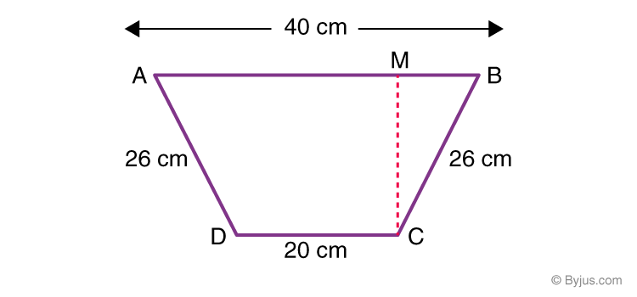

Now, CM will be the distance between the two parallel sides or the height of the trapezium.

We know,

Area of trapezium = ½ × sum of parallel sides × height.

So, height has to be found.

In the diagram, draw CL || AD

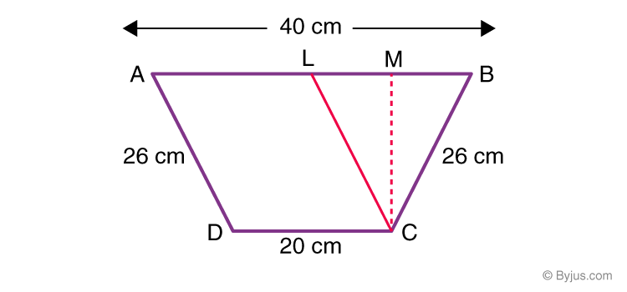

Now, ALCD is a parallelogram ⇒ AL = CD = 20 cm and CL = AD = 26 cm

As AD = CB,

CL = CB ⇒ ΔCLB is an isosceles triangle with CB as its height.

Here, BL = AB – AL = (40 – 20) = 20 cm. So,

LM = MB = ½ BL = ½ × 20 = 10 cm

Now, in ΔCLM,

CL2 = CM2 + LM2 (Pythagoras Theorem)

262 = CM2+ 102

CM2 = 262 – 102

Using algebraic identities, we get; 262 – 102= (26 – 10) (26 + 10)

hence,

CM2 = (26 – 10) (26 + 10) = 16 × 36 = 576

CM = √576 = 24 cm

Now, the area of trapezium can be calculated.

Area of trapezium, ABCD = ½ × (AB + CD) × CM

= ½ × (20 + 40) × 24

Or, Area of trapezium ABCD = 720 cm2

## Class 8 Maths Chapter 11 Mensuration Extra Questions

1. A flooring tile is in the shape of a parallelogram with 24 cm base and the corresponding 10 cm height. Calculate the number of tiles required to cover a floor of area 1080 m2(If required you can split the tiles in whatever way you want to fill up the corners).
2. Two cubes are joined end to end. Now, calculate the volume of the resulting cuboid, if each side of the cubes is 6 cm.
3. How many bricks each 25 cm by 15 cm by 8 cm, are required for a wall 32 m long, 3 m high and 40 cm thick?
4. Find the area of a rhombus whose one side measures 5 cm and one diagonal as 8 cm.

## CHAPTER – 12 – EXPONENTS AND POWERS:

**1. Find the value of (40 + 4-1) × 22**

**Solution:**

(40 + 4-1) × 22 = (1 + ¼) × 4

= 5/4 x 4

= 5

**2. Solve 3-4and (½)-2**

**Solution:**

We know, b-n= 1/bn

So, 3-4= 1/34= 1/81

And, (½)-2 = 1-2/2-2 = 22/12 = 4

**3. Simplify the following expression and express the result in positive power notation:**

**(−4)5 ÷ (−4)8**

**Solution:**

Using am ÷ an = am-n

(−4)5 ÷ (−4)8= (-4)5/(-4)8

⇒ (-4)5-8 = 1/ (-4)3

**4. Evaluate a2 × a3 × a-5**

**Solution:**

a2 × a3 × a-5 = a2+3-5

= a5-5

= a0 = 1

**5. Express 4-3 as a power with base 2.**

**Solution:**

4-3can be written as:

4-3= (22)-3

Now, by using exponential law i.e. (am)n = amn

4-3 = 2-6 (which is in base 2 form).

### Long Answer Type Questions

**6. Evaluate (√4)-3**

**Solution:**

(√4)-3 = (4½)-3

= 4-3/2 = 1/ 43/2

= 1/(43)½ = 1/(64)½

= 1/(82)½ = 1/8

**7. Find the value of x for which 2x ÷ 2-4 = 45**

**Solution:**

Given,

2x ÷ 2-4 = 45

Now, 2x × (½)-4 = (22)5

Or, 2x × (½)-4 = 210

Thus, 2x+4= 210

⇒ x + 4 = 10

Hence, x + 4 = 10

So, x = 6

**8. Calculate the missing value of “x” in the following expression: (11/9)3 × (9/11)6 = (11/9)2x-1**

**Solution:**

Given: (11/9)3 × (9/11)6 = (11/9)2x-1

The multiplier of L.H.S of the equation can be written as:

(11/9)3 × (11/9)-6 = (11/9)2x-1

⇒ (11/9)3-6 = (11/9)2x-1

Therefore, -3 = 2x – 1  
2x = -3 + 1  
x = -2/2  
x = -1

**9. 5 books and 5 paper sheets are placed in a stack. Find the total thickness of the stack if each book has a thickness of 20 mm and each sheet has a thickness of 0.016 mm.**

**Solution:**

Given,

Thickness of 1 book = 20 mm

And,

Thickness of one paper = 0.016 mm

So, thickness of 5 books = 20 x 5 = 100 mm

And,

Thickness of 5 papers = 0.016 × 5 = 0.08 mm

Now, the total thickness of a stack is:

= 100 + 0.08 = 100.08 mm

= 100.08 102 / 102 mm

= 1.0008 × 102mm

**10. If a new-born bear weighs 4 kg, calculate how many kilograms a five-year-old bear weigh if its weight increases by the power of 2 in 5 years?**

**Solution:**

Given,

Weight of new-born bear = 4 kg

Rate of weight increase in 5 years = power to 2

Thus, the weight of the 5-year old bear = 42 = 16 kg

**Q.11: Simplify [25 x t-4]/[5-3 x 10 x t-8]**

Solution:

We can write the given expression as;

[52x t-4]/[5-3 x 5 x 2 x t-8]

= [52 x t-4+8]/[5-3+1 x2]

= [52+2 x t4]/[2]

= [54 x t4]/[2]

= [625/2] t4

**Q.12: Express 0.00000000837 in standard form.**

Solution:

0.00000000837

= 0.00000000837 x 109 / 109

= 8.37 ×10-9

**Q.13: Write 3.61492 x 106in usual form.**

Solution: 3.61492 x 106

= 3.61492 x 1000000

= 3614920

### Maths Class 8 Chapter 12 Extra Questions

1. Evaluate: (-4)-3
2. Simplify: (𝟑-7÷ 𝟑-9) × 𝟑-4
3. Find the value of (37 + 4-3 + 53)0
4. Evaluate: [{1/2}-1+{1/3}-1]-1
5. Express 31860000000 in standard form.
6. Find x so that (-5)x+1 × (-5)5 = (-5)7
7. Solve the following: (81)-4 ÷ (729)2-x = 94x

## CHAPTER – 13 – DIRECT AND INVERSE PROPORTION:

**1. If the increase in time causes a corresponding decrease in the price of a product. Identify the proportionality.**

**Solution:**

As per the given question, the increase in time reduces the price of a product. Thus,

**Time ∝ 1/Product Price**

Hence, the time and price of the product are inversely proportional.

**2. Identify the variation: “For the increase in speed, the time to cover a fixed distance reduces”.**

**Solution:**

In this case, an increase in speed results in a decrease in time. So,

**Speed ∝ 1/Time**

So, this relation is a case of indirect variation.

**3. If the cost of 20 pens is Rs. 180, calculate the cost of 15 pens?**

**Solution:**

Given that 20 pens cost Rs. 180.

Now, let the cost of 15 pens be Rs. x

In such a condition, the cost of pens changes directly with the total number of pens i.e. they are directly proportional.

So,

20/180 = 15/x

Or, x = Rs. 135.

**4. A car travels 14 km in 25 minutes. Find out how far the car can travel in 5 hours if the speed remains the same?**

**Solution:**

It is given that the car travels 14 km in 25 minutes.

Now, assume that the distance the car can travel in 5 hours be x.

Since 1 hour = 60 minutes, 5 hours = 300 minutes.

Thus, the two given statements are

14 km —————–> 25 minutes

And, x km —————–> 300 minutes

We know that the distance travelled by car and the time taken by the car is directly proportional to each other.

So,

14/25 = x/300

=> x = 168 km.

**5. If 15 workers can finish a task in 42 hours, calculate the number of workers required to complete the same task in 30 hours.**

**Solution:**

In this situation, the number of workers varies indirectly with the time required to finish a task.

Thus, they are inversely proportional.

Now, assume that the number of workers required to complete the task in 30 hours be “x”.

Here, the number of workers ∝ 1/hours

Or,

Number of workers = C/hours (here “C” is the constant of proportionality)

Now, consider the first case: “15 workers can finish a task in 42 hours”

Here, 15 = C/42

=> C = 15 × 42 = 630.

Now, consider the second case: “x workers can finish a task in 30 hours”

Here, x = C/30

=> x = 630/30

Or, x = 21

So, the number of 21 workers are required to complete the task in 30 hours.

### Class 8 Maths Chapter 13 Extra Question

1. If a horse eats 18 kg of com in 12 days ? What is the quantity it eats in 9 days ?  
(a) 12.5 kg  
(b) 11.5 kg  
(c) 12.5 kg  
(d) 13.5 kg

2. If 8 g of sandal wood cost Rs 40, what is the cost of 10 g ?  
(a) Rs 50  
(b) Rs 36  
(c) Rs 48  
(d) Rs 30

3. If a boy can run 1 km in 10 minutes. How long will he take to run 600 m?  
(a) 4 minutes  
(b) 2 minutes  
(c) 3 minutes  
(d) 6 minutes

4. 3 lambs finish eating turnips in 8 days. How many days will it take for 2 lambs to finish them?  
(a) 8  
(b) 6  
(c) 12  
(d) 10

## CHAPTER – 14 – FACTORISATION:

**1.** **Express the following as in the form of (a+b)(a-b)**

**(i) a2 – 64**

**(ii) 20a2 – 45b2**

**(iii) 32x2y2 – 8**

**(iv) x2 – 2xy + y2 – z2**

**(v) 49x2 – 1**

**Solution:**

For representing the expressions in (a+b)(a-b) form, use the following formula

a2 – b2 = (a+b)(a-b)

(i) a2 – 64 = a2 – 82= (a + 8)(a – 8)

(ii) 20a2 – 45b2 = 5(4a2 – 9b2) = 5(2a + 3b)(2a – 3b)

(iii) 32x2y2 – 8 = 8( 4x2y2 – 1) = 8(2xy + 1)(2xy – 1)

(iv) x2 – 2xy + y2 – z2 = (x – y)2 – z2= (x – y – z)(x – y + z)

(v) 49x2 – 1 = (7x)2 – (1)2 = (7x + 1)(7x – 1)

**2. Verify whether the following equations are correct. Rewrite the incorrect equations correctly.**

**(i) (a + 6)2 = a2 + 12a + 36**

**(ii) (2a)2 + 5a = 4a + 5a**

**Solution:**

(i) (a + 6)2 = a2 + 12a + 36

Here, LHS = (a + 6)2 = a2 + 12a + 36

Now, RHS = a2 + 12a + 36

Hence, LHS = RHS.

(ii) (2a)2 + 5a = 4a + 5a

Here, LHS = (2a)2 + 5a = 4a2 + 5a

Now, RHS = 4a + 5a

So, LHS ≠ RHS

Correct equation: (2a)2 + 5a = 4a2 + 5a

**3. For a = 3, simplify a2 + 5a + 4 and a2 – 5a**

**Solution:**

Substitute the value of a = 3 in the given equations.

a2 + 5a + 4 = 32 + 5(3) + 4 = 9 + 15 + 4 = 28

And,

a2 – 5a = 32 – 5(3) = 9 – 15 = -6

### Long Answer Type Questions:

**4. Find the common factors of the following:**

**(i) 6 xyz, 24 xy2 and 12 x2y**

**(ii) 3x2 y3, 10x3y2 and 6x2 y2 z**

**Solution:**

(i) 6 xyz = 2 × 3 × x × y × z

24 xy2 = 2 × 2 × 2 × 3 × x × y × y

12 x2y = 2 × 2 × 3 × x × x × y

Thus, the common factors are common factors of 6 xyz, 24 xy2 and 12 x2y are 2, 3, x, y and, (2 × 3 × x × y) = 6xy

(ii) 3x2 y3 = 3 × x × x × y × y × y

10x3 y2 = 2 × 5 × x × x × x × y × y

6 x2 y2 z = 3 × 2 × x × x × y × y × z

Now, the common factors of 3x2 y3, 10x3y2 and 6x2 y2 z are x2, y2 and, (x2 × y2) = x2 y2

**5. Factorize the following expressions:**

**(i) 54x3y + 81x4y2**

**(ii) 14(3x – 5y)3 + 7(3x – 5y)2**

**(iii) 15xy + 15 + 9y + 25x**

**Solution:**

(i) 54x3y + 81x4y2

= 2 × 3 × 3 × 3 × x × x × x × y + 3 × 3 × 3 × 3 × x × x × x × x × y × y

= 3 × 3 × 3 × x × x × x × y × (2 + 3 xy)

= 27x3y (2 + 3 xy)

(ii) 14(3x – 5y)3 + 7(3x – 5y)2

= 7(3x – 5y)2 [2(3x – 5y) +1]

= 7(3x – 5y)2 (6x – 10y + 1)

(iii) 15xy + 15 + 9y + 25x

Rearrange the terms as:

15xy + 25x + 9y + 15

= 5x(3y + 5) + 3(3y + 5)

Or, (5x + 3)(3y + 5)

**6. Factorize (x + y)2 – 4xy**

**Solution:**

To solve this expression, expand (x + y)2

Use the formula:

(x + y)2 = x2 + 2xy + y2

(x + y)2 – 4xy = x2 + 2xy + y2 – 4xy

= x2 + y2 – 2xy

We know, (x – y)2 = x2 + y2 – 2xy

So, factorization of (x + y)2 – 4xy = (x – y)2

**7. Factorize x2 + 6x – 16**

**Solution:**

To factorize, it should be checked that the sum of factors of 16 should be equal to 6.

Here, 16 = -2 × 8 and 8 + (-2) = 6

So,

x2 + 6x – 16 = x2 – 2x + 8x – 16

= x(x – 2) + 8(x – 2)

= (x + 8) (x – 2)

Hence, x2 + 6x – 16 = (x + 8) (x – 2)

**8. Solve for (4x2 – 100) ÷ 6(x + 5)**

**Solution:**

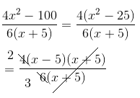

= ⅔ (x – 5)

## Class 8 Maths Chapter 14 Extra Questions

1. Factorise:  
   (а) 14m5n4p2 – 42m7n3p7 – 70m6n4p3  
   (b) 2a2(b2 – c2) + b2(2c2 – 2a2) + 2c2(a2 – b2)
2. The area of a rectangle is 6a2+ 36a and 36a width. Find the length of the rectangle.
3. What are the common factors of the following terms?  
   (a) 25x2y, 30xy2  
   (b) 63m3n, 54mn4

## CHAPTER – 15 – INTRODUCTION TO GRAPHS:

**Q.1: The following line graph shows the yearly sales figures for a manufacturing company.**

**(a) What were the sales in (i) 2002 (ii) 2006?**

**(b) What were the sales in (i) 2003 (ii) 2005?**

**(c) Compute the difference between sales in 2002 and 2006.**

**(d) In which year was there the greatest difference between the sales as compared to its previous year?**

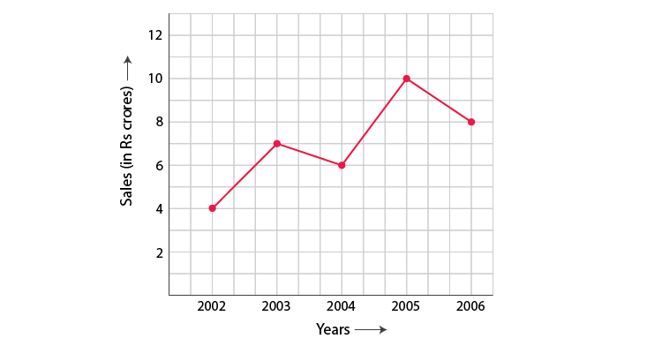

Solution:

(a) The sales in (i) 2002 were Rs. 4 crores and (ii) 2006 was Rs. 8 crores

(b) The sales in (i) 2003 was Rs. 7 crores and (ii) 2005 was Rs.10 crores.

(c) The difference of sales in 2002 and 2006 = Rs. 8 crores – Rs. 4 crores = Rs. 4 crores

(d) In the year 2005, there was the greatest difference between the sales and compared to its previous year, which is (Rs. 10 crores – Rs. 6 crores) = Rs. 4 crores.

**Q.2: Use the tables below to draw linear graphs:**

**(a) The number of days a hillside city received snow in different years.**

|  |  |  |  |  |
| --- | --- | --- | --- | --- |
| **Year** | **2003** | **2004** | **2005** | **2006** |
| **Days** | **8** | **10** | **5** | **12** |

**(b)Population (in thousands) of men and women in a village in different years.**

|  |  |  |  |  |  |
| --- | --- | --- | --- | --- | --- |
| **Year** | **2003** | **2004** | **2005** | **2006** | **2007** |
| **No. of men** | **12** | **12.5** | **13** | **13.2** | **13.5** |
| **No. of women** | **11.3** | **11.9** | **13** | **13.6** | **12.8** |

Solution:

a) Consider “Years” along the x-axis and “Days” along the y-axis. Using the given information, the linear graph will look like:

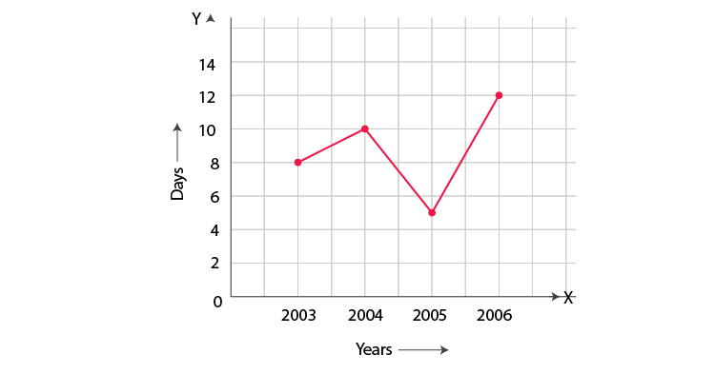

b) Consider “Years” along the x-axis and “No. of Men and No. of Women” along the y-axis (2 graphs). Using the given information, the linear graph will look like:

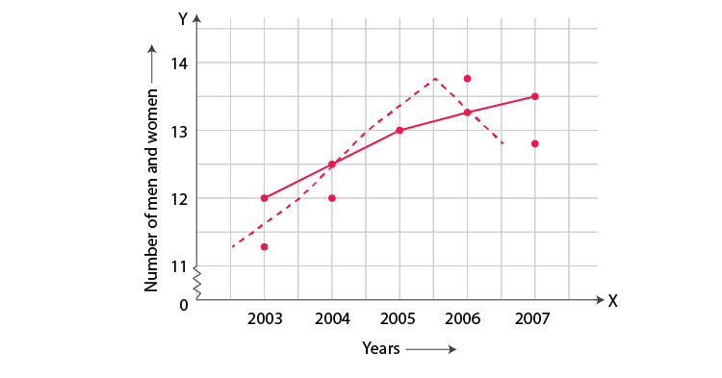

**Q.3: Plot the point (4, 3) on a graph sheet. Is it the same as the point (3, 4)?**

Solution:

Locate the x, y axes, (they are actually number lines!). Start at O (0, 0). Move 4 units to the right; then move 3 units up, you reach the point (4, 3). From Fig 15.13, you can see that the points (3, 4) and (4, 3) are two different points.

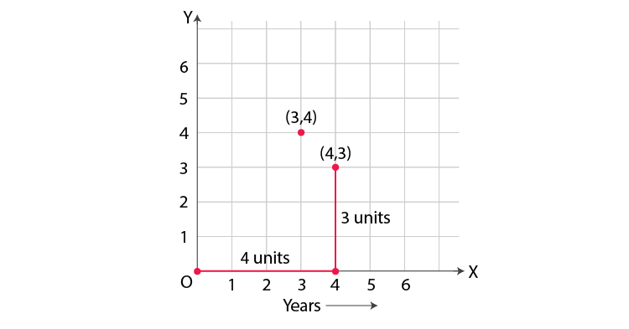

**Q.4: Plot the following points on a graph sheet. Verify if they lie on a line:**

**(a) A(4,0), B(4, 2),C(4,6), D(4, 2.5)**

**(b) P(1, 1), Q(2, 2), R(3,3), S(4, 4)**

**(c) K(2, 3), L(5, 3), M(5,5), N(2, 5)**

Solution:

Plot all the points on the graph.

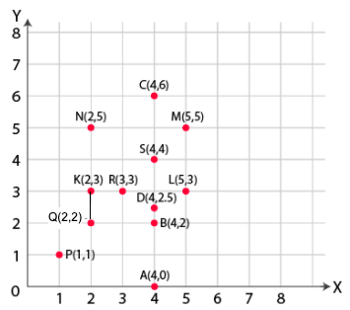

(a) All points A, B, C and D lie on a vertical line.

(b) P, Q, R and S points also make a line. It verifies that these points lie on a line.

(c) Points K, L, M and N do not lie in a straight line

**Q.5: Draw the line passing through (2,3) and (3,2). Find the coordinates of the points at which this line meets the x-axis and y-axis.**

Solution:

Graph for the Line passes through points (2, 3) and (3, 2) is:

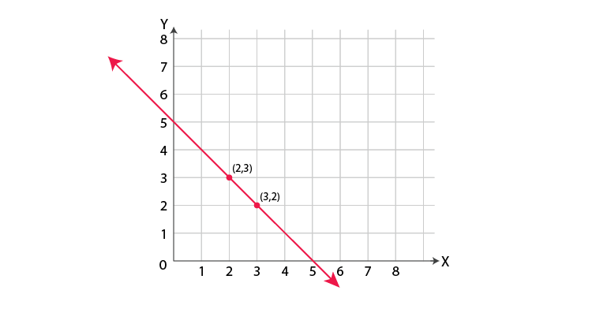

The coordinates of the points at which this line meets the x-axis at (5, 0) and Y axis at (0, 5).

**Q.6: Draw the graphs for the following table of values, with suitable scales on the axes.**

**Interest on deposits for a year.**

|  |  |  |  |  |  |
| --- | --- | --- | --- | --- | --- |
| **Deposit (in Rs.)** | **1000** | **2000** | **3000** | **4000** | **5000** |
| **Simple interest (in Rs.)** | **80** | **160** | **240** | **320** | **400** |

**(i) Does the graph pass through the origin?**

**(ii) Use the graph to find the interest on Rs 2500 for a year.**

**(iii) To get an interest of Rs. 280 per year, how much money should be deposited?**

Solution:

Represent “Deposit” on y-axis and “simple interest” on x-axis.

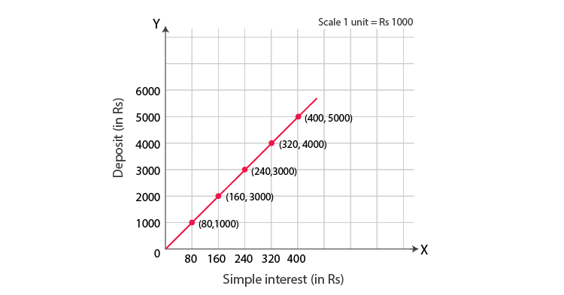

(i) Yes, the graph passes through the origin.

(ii) Interest on Rs. 2500 is Rs. 200 for a year.

(iii) Rs. 3500 should be deposited for the interest of Rs. 280

### Extra Questions For Class 8 Maths Chapter 15

* 1. Plot the following points and verify if they lie on a line. If they lie on a line, name it.

(i) (0, 2), (0, 5), (0, 6), (0, 3.5)

(ii) A (1, 1), B (1, 2), C (1, 3), D (1, 4)

(iii) K (1, 3), L (2, 3), M (3, 3), N (4, 3)

(iv) W (2, 6), X (3, 5), Y (5, 3), Z (6, 2)

* 1. State whether True or False. Correct that is false.

(i) A point whose x coordinate is zero and y-coordinate is non-zero will lie on the y-axis.

(ii) A point whose y coordinate is zero and x-coordinate is 5 will lie on y-axis.

(iii) The coordinates of the origin are (0, 0)

* 1. A bank gives 10% Simple Interest (S.I.) on deposits by senior citizens. Draw a graph to illustrate the relation between the sum deposited and simple interest earned. Find from your graph

(a) the annual interest obtainable for an investment of ` 250.

(b) the investment one has to make to get an annual simple interest of ` 70.

* 1. Draw a graph for the following.

|  |  |  |  |  |  |
| --- | --- | --- | --- | --- | --- |
| Side of the square(in cm) | 2 | 3 | 3.5 | 5 | 6 |
| Perimeter (in cm) | 8 | 12 | 14 | 20 | 24 |

Is it a linear graph?

5. Write the coordinates of each point shown is the graph.

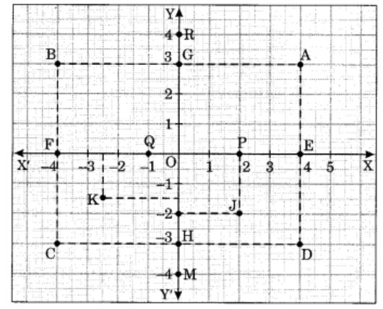

## CHAPTER – 16 – PLAYING WITH NUMBERS:

**Question 1: Express 3458 in a generalized form.**

**Ans:**3458 will be written in a generalized way in the following manner,

3458 = 3 x 10 3 + 4 x 102 + 5 x 101+ 8 x 100

**Question 2: Express the given number in a normal form: (2 x 1000) + (2 x 10)**

**Ans:**(2 x 1000) + (2 x 10) will be written in a normal form in the following way:

(2 x 1000) + (2 x 10) = 2000 + 20 = 2020

**Question 3: If the number 1220 is divided by 13, find the quotient and remainder.**

**Solution :** dividend = pq + r

1220 = 13 × 93 + 11

Quotient = 93

Remainder = 11

**Question 4: What is the least natural number which is larger than 100 and which leaves the remainder, R = 12 when it is divided by 19.**

**Ans:**100 = 19 × 5 + 5

As 5 + 7 = 12, and the required number is 100 + 7 = 107

**Question 5: What is the smallest number you have to add to 100000 to get a multiple of 1234?**

**Ans:**100000 = 1234 × 81 + 46

Thus, 1234 – 46 = 1188.

Hence, the required number is 1188.

**Question 6: How many numbers from 1001 to 2000 are divisible by 4?**

**Ans:**1004, 1008, 1012, 1016… are the numbers between 1001 and 2000 which are divisible by 4.

Therefore, there will be (2000-1004) /4 + 1 = 250 numbers between 1001 and 2000, and these will be divisible by 4.

**Question 7: Show that if a palindrome is 4 digits, it would be divisible by 11?**

**Ans:**Let us assume abba is the four-digit palindrome.

So, abba = a x 1000 + b x 100 + b x 10 + a

= 1001a +110b

= 91 x 11a + 110b

= 11 x (91a + 10b)

Hence Proved.

**Question 8: Make a 5 digit number using each of the digits 4,5,6,7,8. Also, see that the number made shall be divisible by 132.**

**Ans:**132 can be written as 11 x 12 = 3 x 4 x 11

As 4 + 5+ 6+ 7+ 8 = 30, the numbers formed by the 4,5,6,7,8 are all divisible by 3.

Let’s check the divisibility by 11 and 4.

If the number is divisible by 4, then the last 2 digits of the number formed are divisible by 4.

Similarly, if the difference between the sum of digits placed at even and the sum of digits placed at odd places is divisible by 11, then the number is divisible by 11.

i.e. 67584 and 57684

**Question 9. By which number 345111 is divisible among the given options – 15, 12, 3, 9.**

**Ans:**Add all the digits in the number given – 345111

345111 + 3+4+5+1+1+1 = 15, which is divisible by 3. So, 3 is the correct option.

**Question 10: Can you tell a 5 digit number which will be divisible by 11 and it should have digits 2,3,4,5,6?**

**Ans:**

So now, 2 – 4 + 3 – 6 + 5 = 0, so 24365 is the least 5 digit number which is also divisible by 11.

Consider the number 24365 formed by the digits 2, 3, 4, 5 and 6

Here, 2 − 4 + 3 − 6 + 5 = 0

Thus, 24365 is the smallest number divisible by 11.

**Question 11: Check the divisibility of 21436587 by 9.**

Ans: The sum of the digits of 21436587 is 2 + 1 + 4 + 3 + 6 + 5 + 8 + 7 = 36.  
This number is divisible by 9 (for 36 ÷ 9 = 4).

Hence, 21436587 is divisible by 9.

Check: 21436587/9 = 2381843

**Question 12: Check the divisibility of 2146587 by 3.**

**Ans:**

The sum of the digits of 2146587 is 2 + 1 + 4 + 6 + 5 + 8 + 7 = 33.

This number is divisible by 3 (for 33 ÷ 3 = 11).

Hence, 2146587 is divisible by 3

**Question 13: If 31z5 is a multiple of 9, where z is a digit, what is the value of z? You will find that there are two answers to the last problem. Why is this so?**

**Ans:**

Given, 31z5 is a multiple of 9.  
Therefore, according to the divisibility rule of 9, the sum of all the digits should be a multiple of 9.  
3 + 1 + z + 5 = 9 + z  
Therefore, 9 + z is a multiple of 9.  
This is only possible when 9 + z is any one of these numbers: 0, 9, 18, 27, and so on.  
This implies, 9 + 0 = 9 and 9 + 9 = 18  
Hence 0 and 9 are two possible answers.

**Question 14: If 31z5 is a multiple of 3, where z is a digit, what might be the values of z?**

**Ans:**

Given, 31z5 is a multiple of 3.  
Therefore according to the divisibility rule of 3, the sum of all the digits should be a multiple of 3.  
That is, 3 + 1 + z + 5 = 9 + z  
Therefore, 9 + z is a multiple of 3.  
This is possible when the value of 9 + z is any of the values: 0, 3, 6, 9, 12, 15, and so on.  
At z = 0, 9 + z = 9 + 0 = 9  
At z = 3, 9 + z = 9 + 3 = 12  
At z = 6, 9 + z = 9 + 6 = 15  
At z = 9, 9 + z = 9 + 9 = 18  
The value of 9 + z can be 9 or 12 or 15 or 18.  
Hence 0, 3, 6 or 9 are four possible answers for z.

**Extra Questions for Class 8 Maths Chapter 16**

* + 1. If 21y5 is a multiple of 9, where y is a digit, what is the value of y?
    2. If 24x is a multiple of 3, where x is a digit, what is the value of x?
    3. Check the divisibility of the following numbers by 3.
       - 108
       - 616
       - 294
       - 432
       - 927
    4. If the division of N+5 gives a remainder of 1, calculate the one’s digit of N?

(a) either 7 or 2  
(b) 1  
(c) 6  
(d) 5

                 5.  Is 6582 divisible by 4?